# [**Setting Up Facebook Authentication in Firebase for a Test Game**](https://app.tango.us/app/workflow/ae089d84-2101-46fc-9f56-c5f310841a1e?utm_source=magicCopy&utm_medium=magicCopy&utm_campaign=workflow%20export%20links)

**Creation Date:** Jan 02, 2025

**Created By:** Chester Lok

[View most recent version on Tango.us](https://app.tango.us/app/workflow/ae089d84-2101-46fc-9f56-c5f310841a1e?utm_source=magicCopy&utm_medium=magicCopy&utm_campaign=workflow%20export%20links)

​

​

## [**# Firebase console**](https://console.firebase.google.com/?_gl=1*1c6nyk1*_ga*MTQyMDc0NjQzNi4xNzMzMjQyMjM1*_ga_CW55HF8NVT*MTczNTgwNDM5OS45LjAuMTczNTgwNDQwMy41Ni4wLjA.)

### **1. Click on add…**

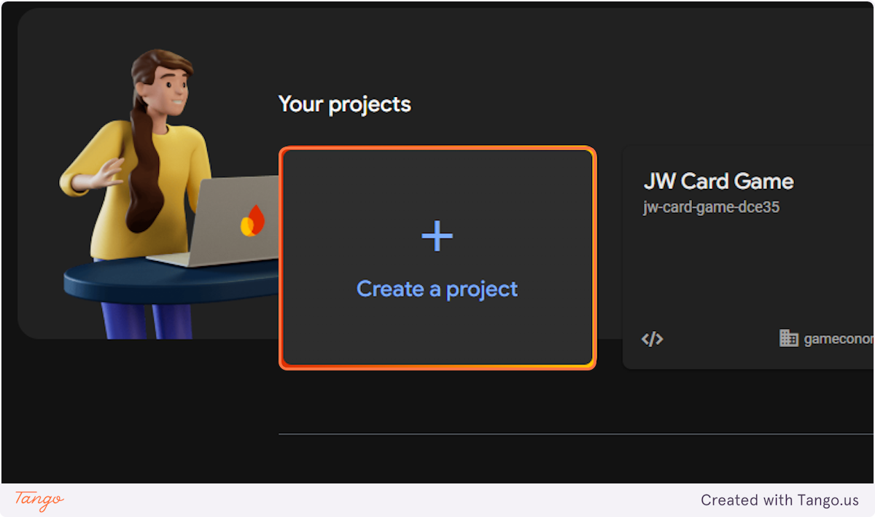

### **2. Type "Test Game"**

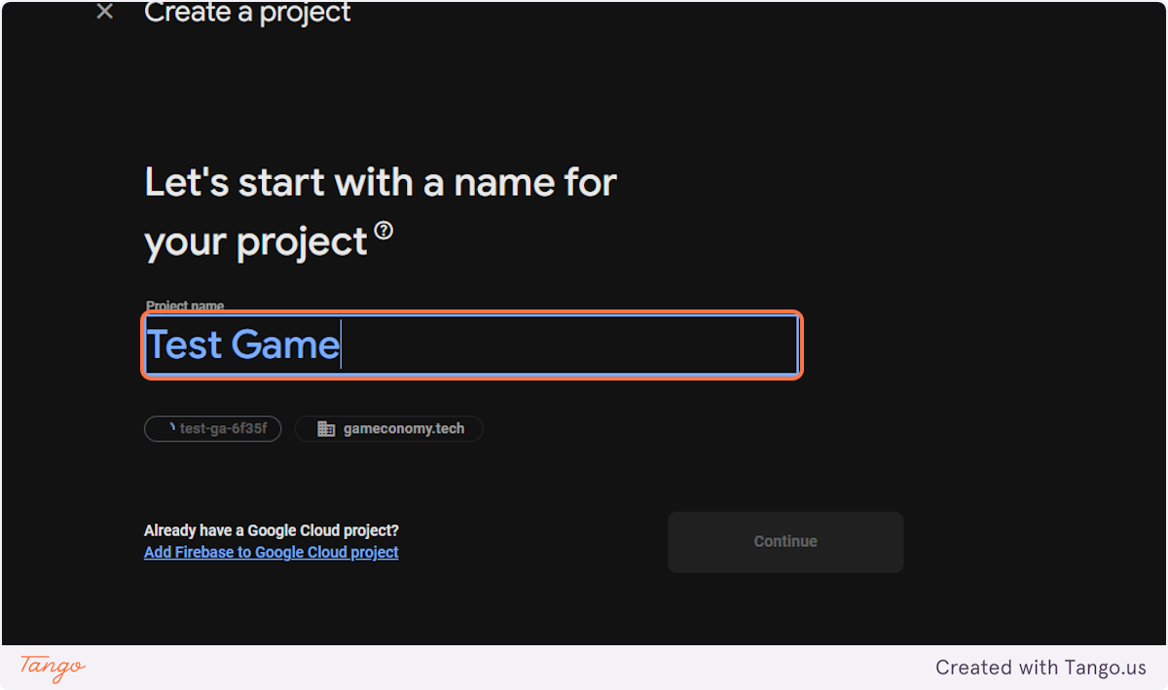

### **3. Click on Continue**

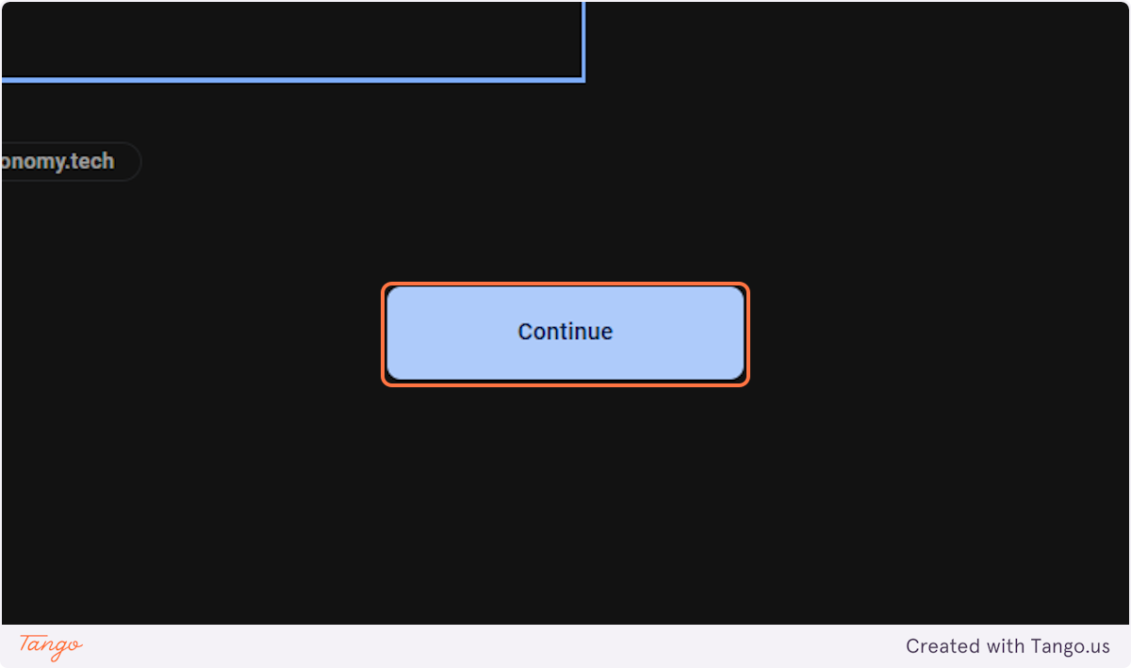

### **4. Click on Continue**

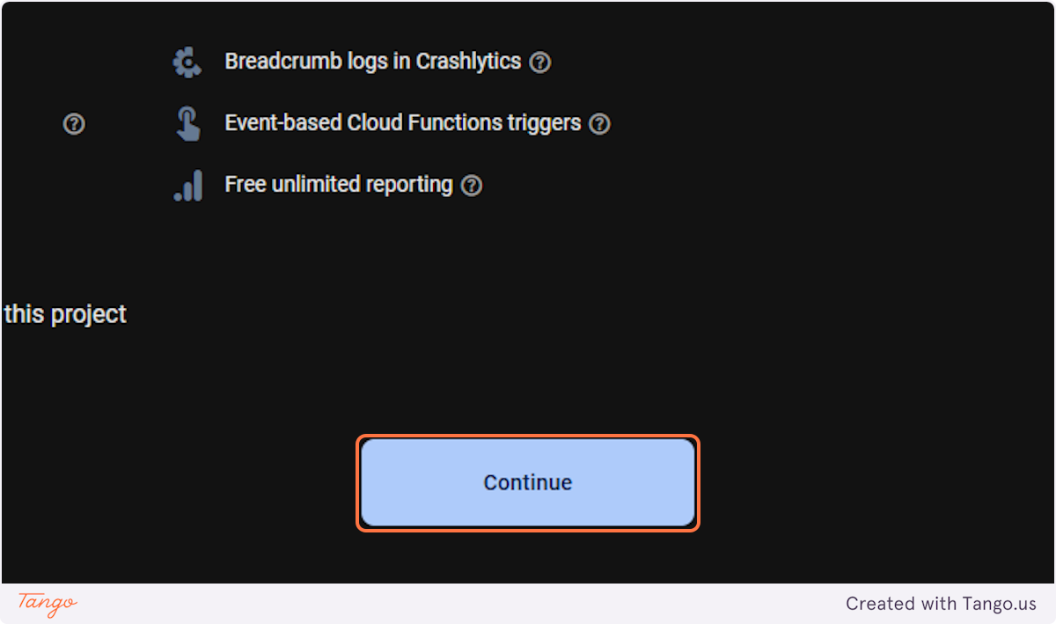

### **5. Click on Select an account…**

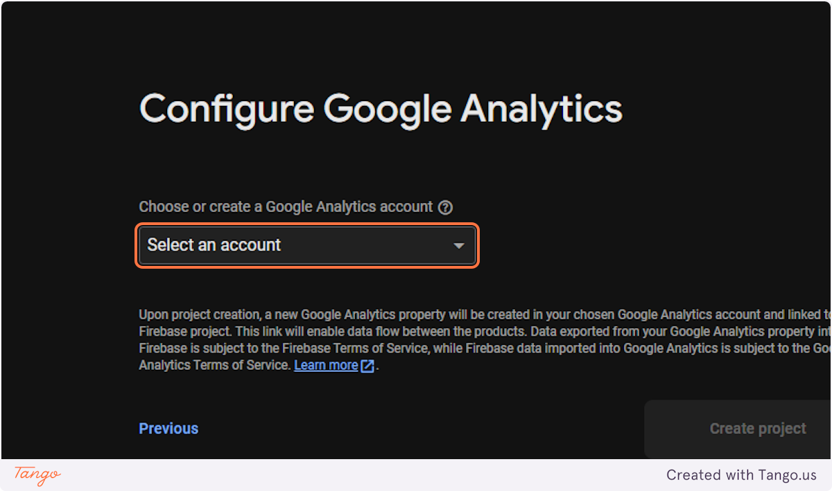

### **6. Click on Default Account for Firebase**

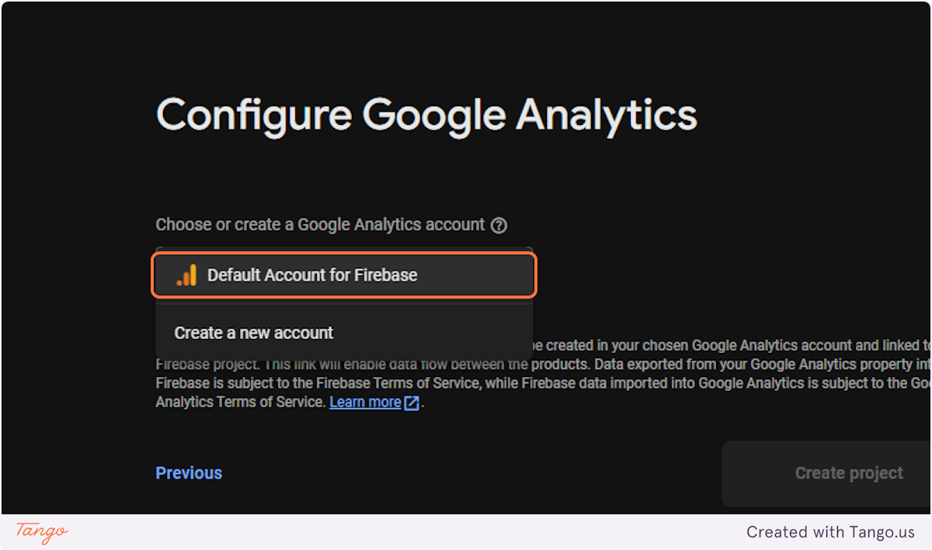

### **7. Click on Create project**

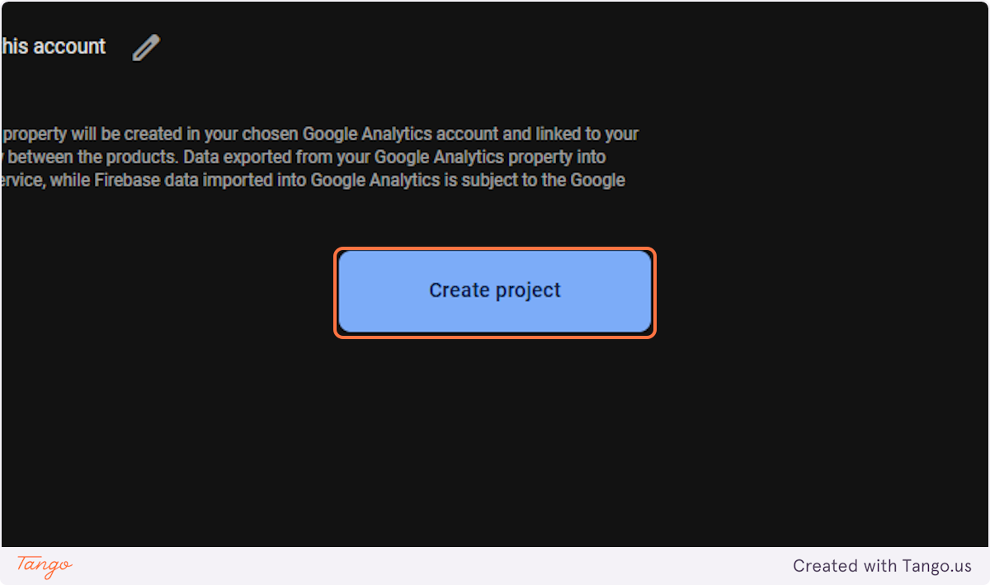

### **8. Click on Continue**

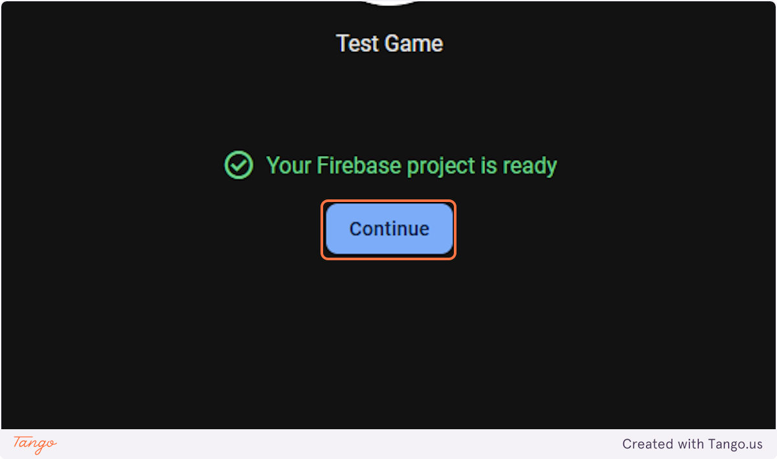

### **9. Click on apps…**

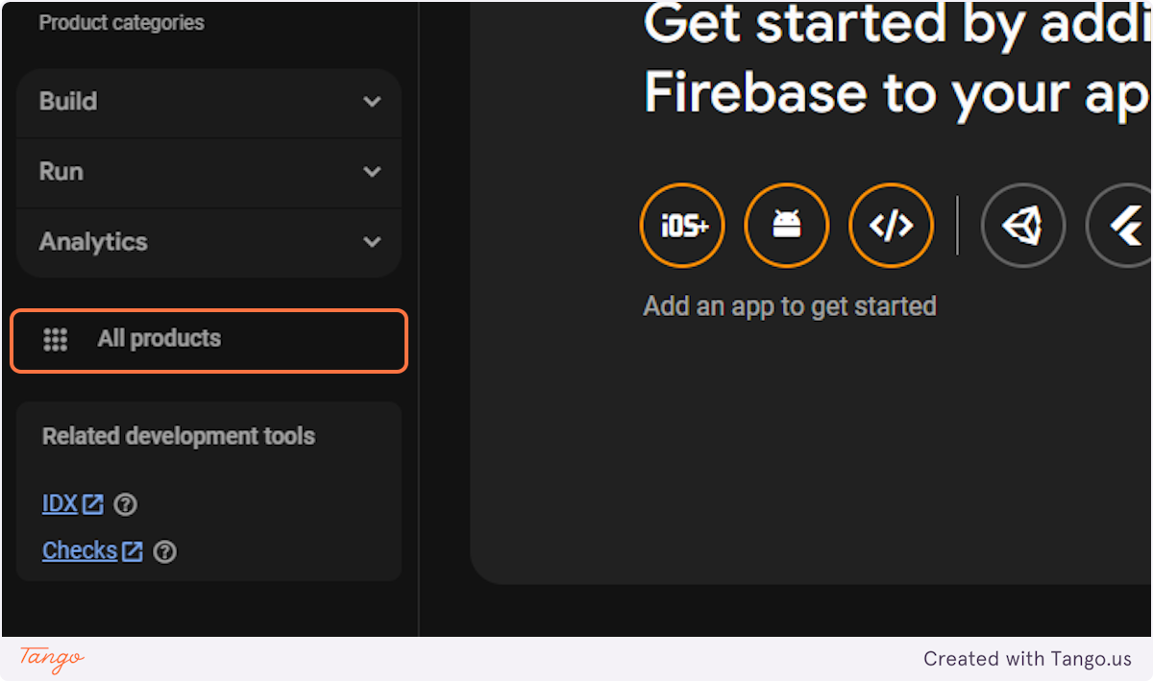

### **10. Click on Authentication…**

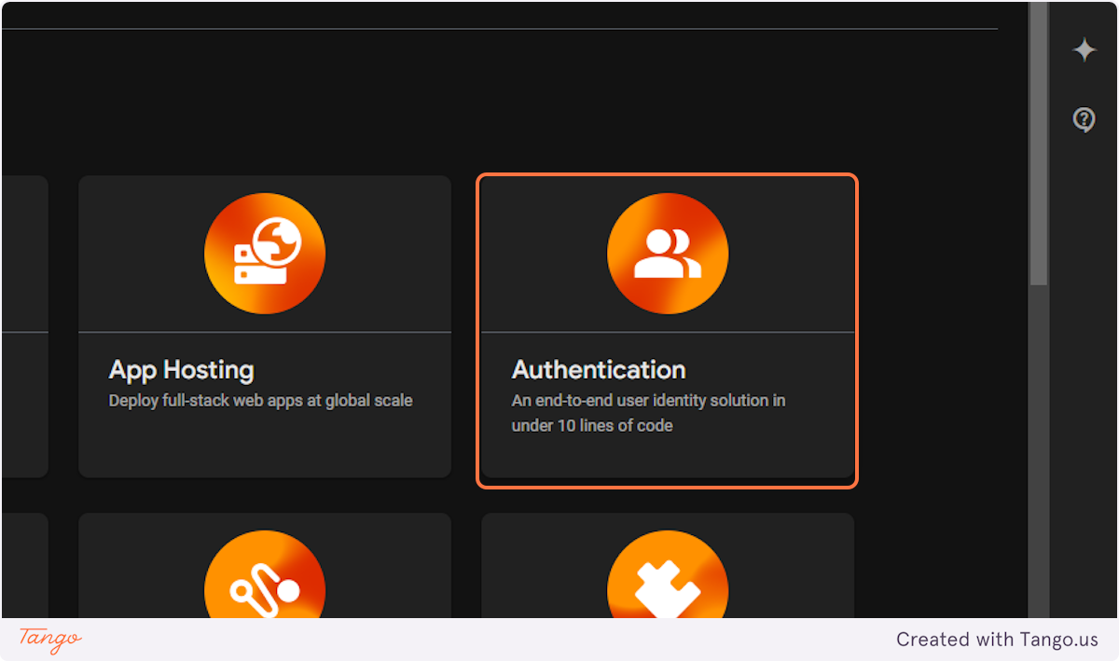

### **11. Click on Get started**

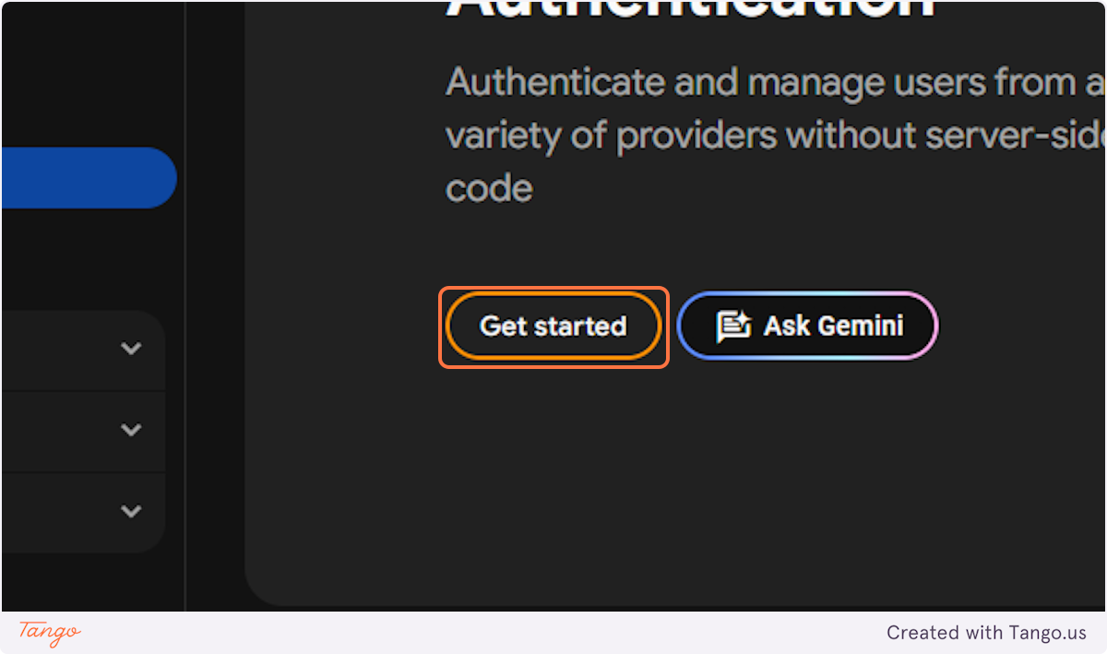

### **12. Click on Facebook**

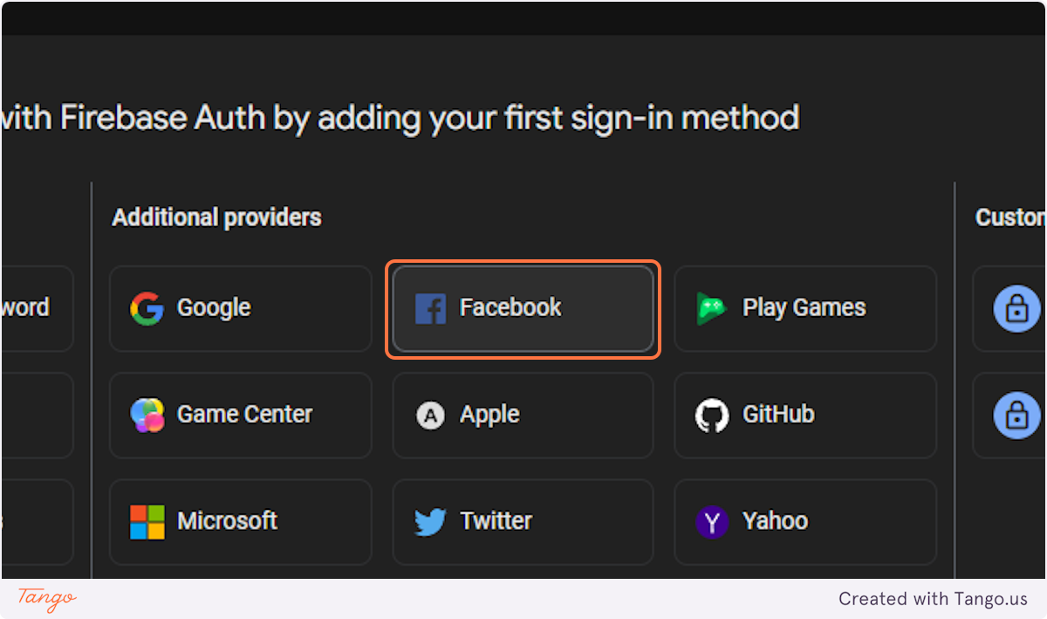

### **13. Click on My Apps**

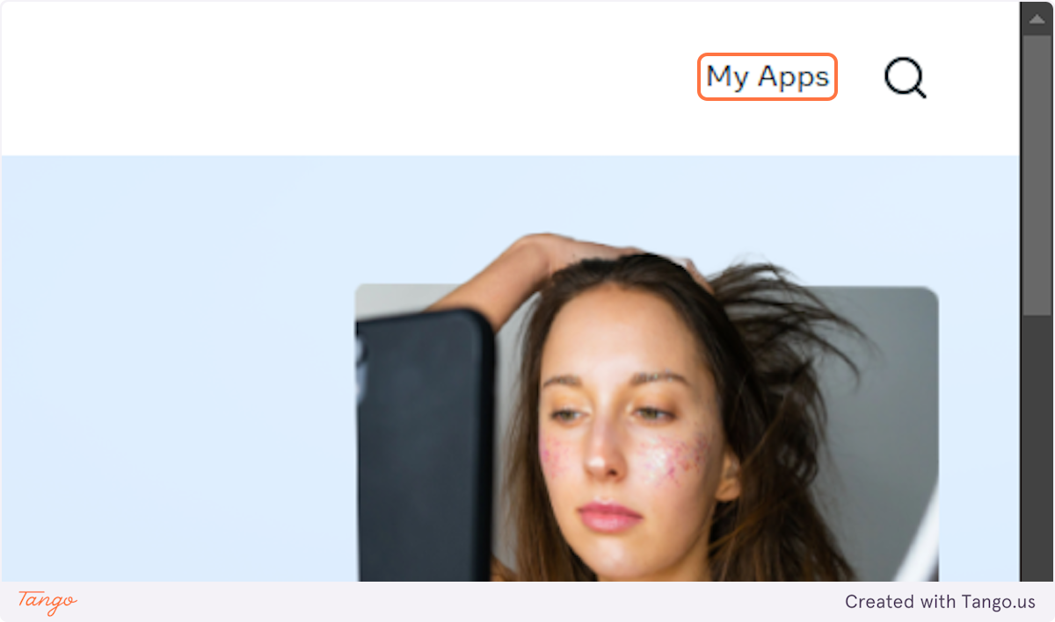

### **14. Click on Create App**

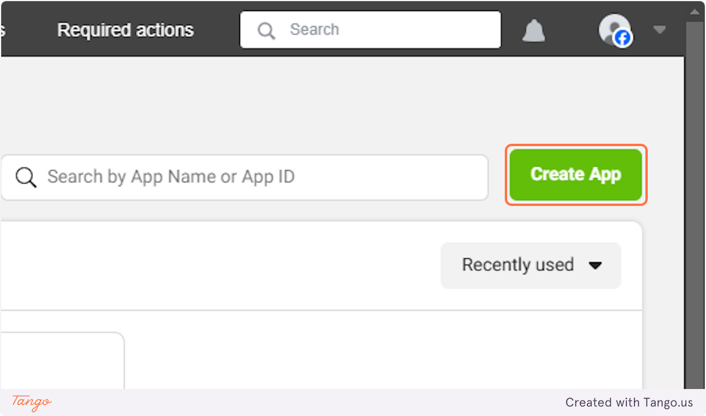

### **15. Type "Sample App"**

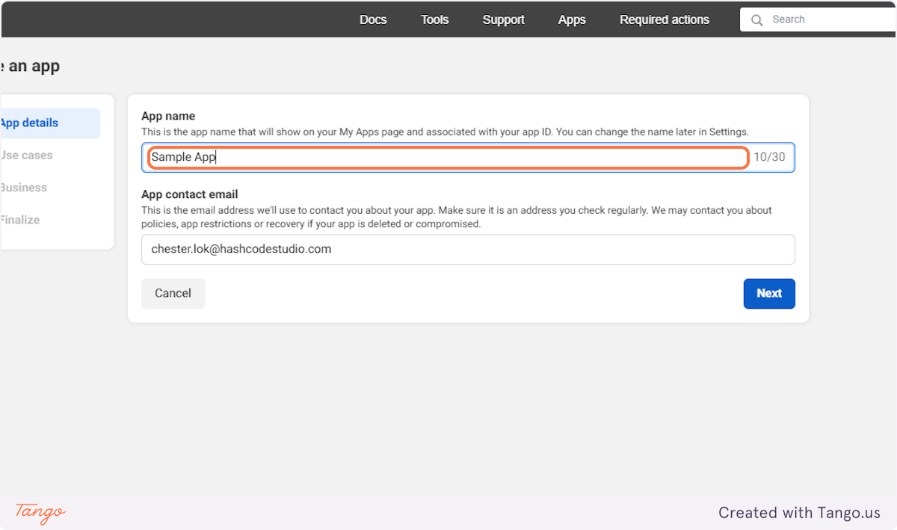

### **16. Click on Next**

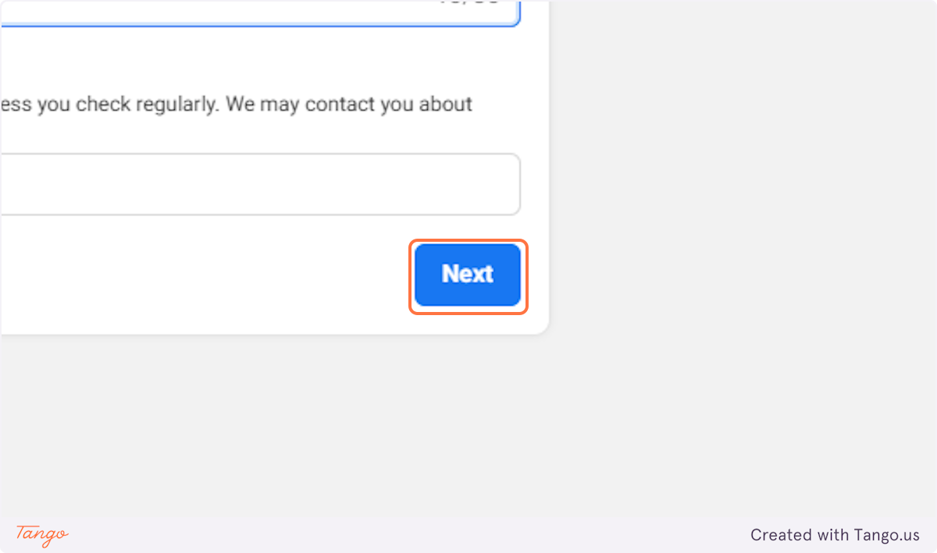

### **17. Click on Authenticate and request data from users with Facebook Login…**

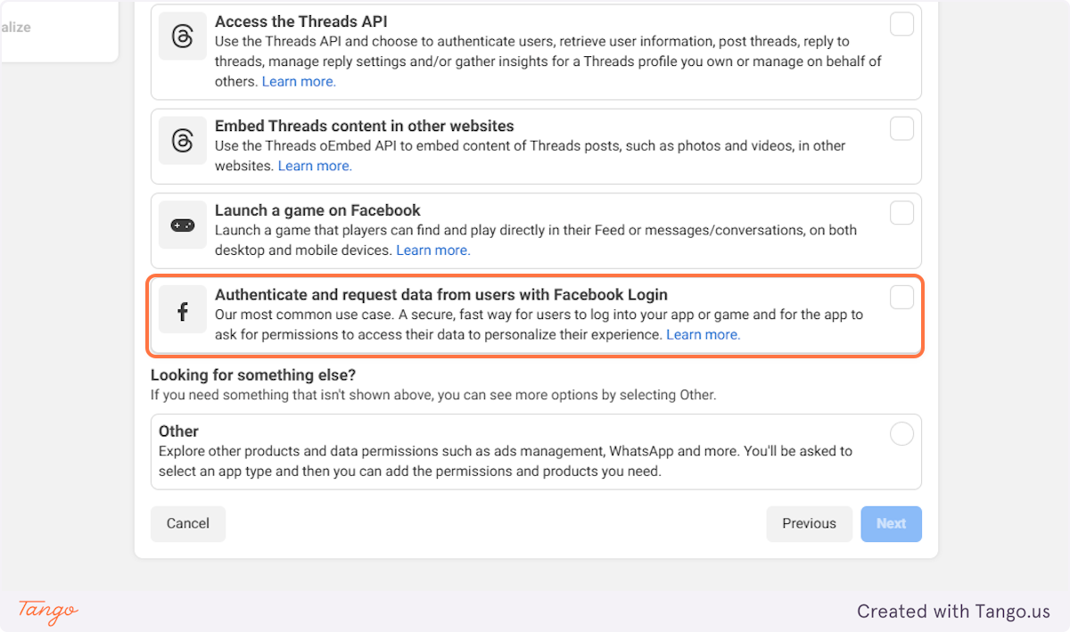

### **18. Click on Next**

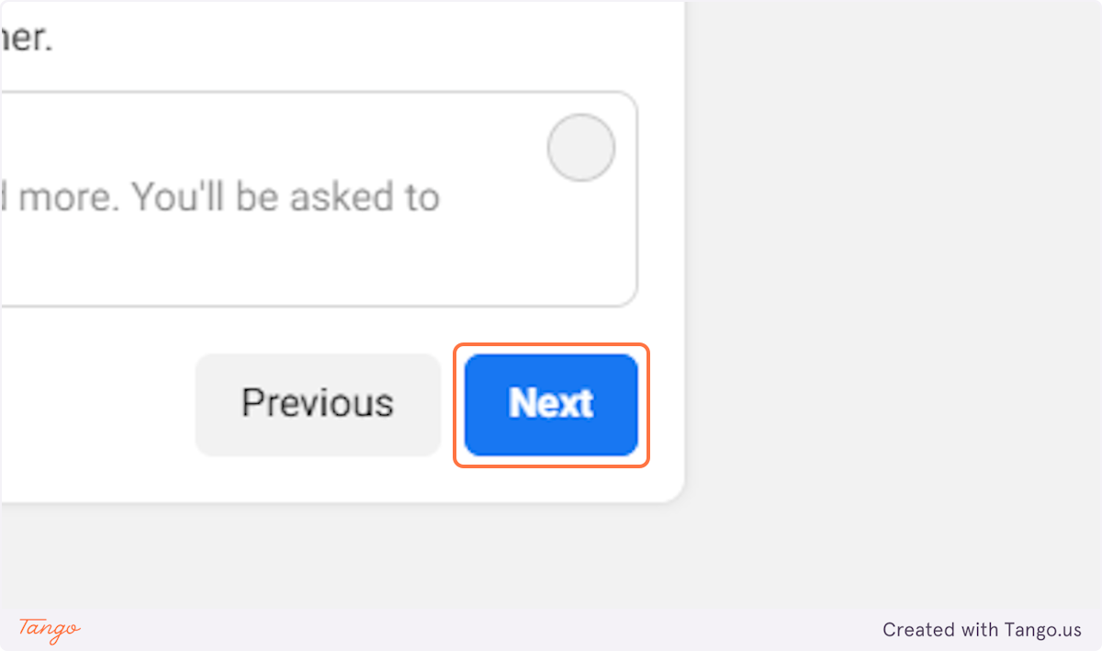

### **19. Select I don’t want to connect a business portfolio yet.**

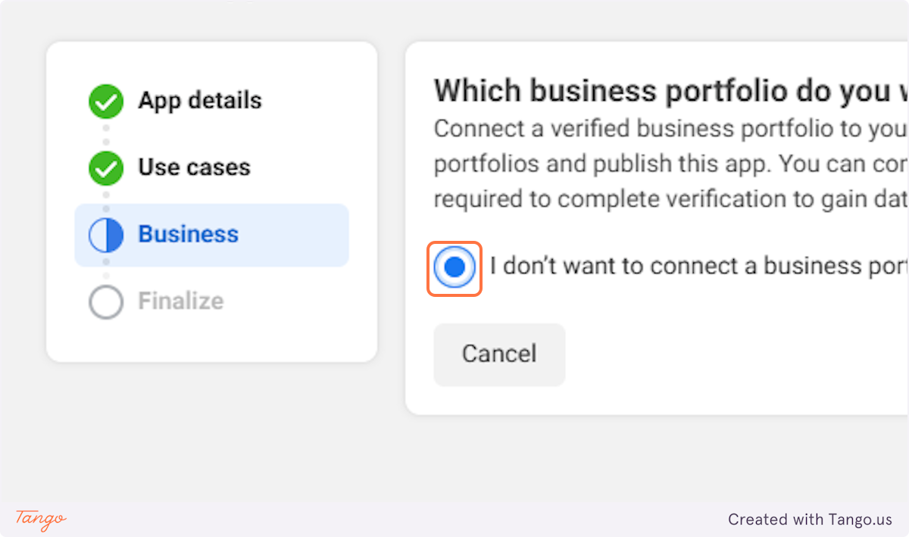

### **20. Click on Next**

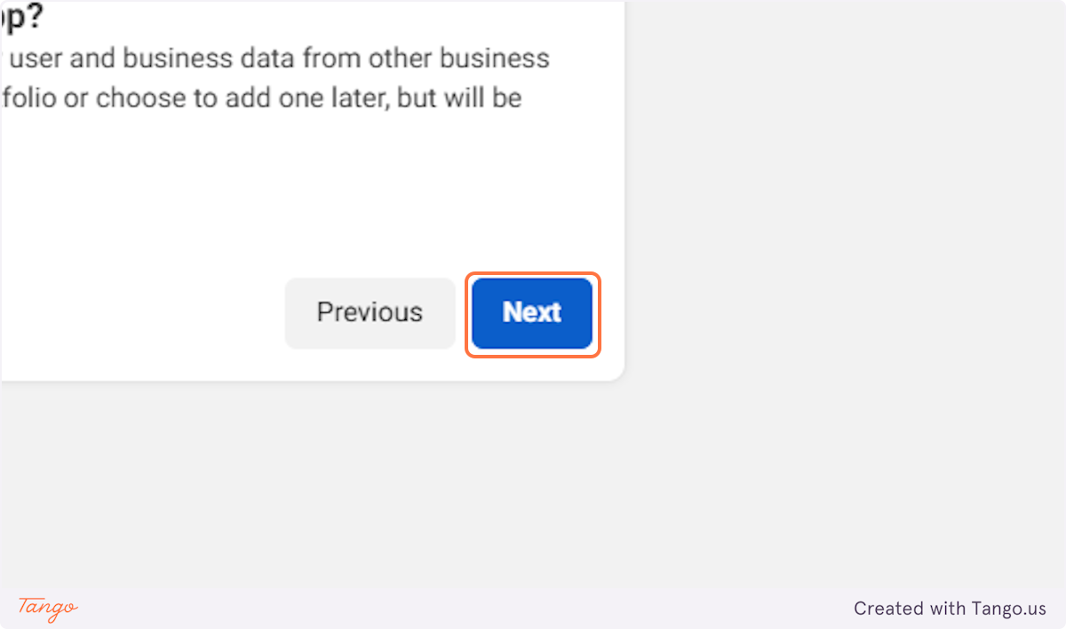

### **21. Click on Go to dashboard**

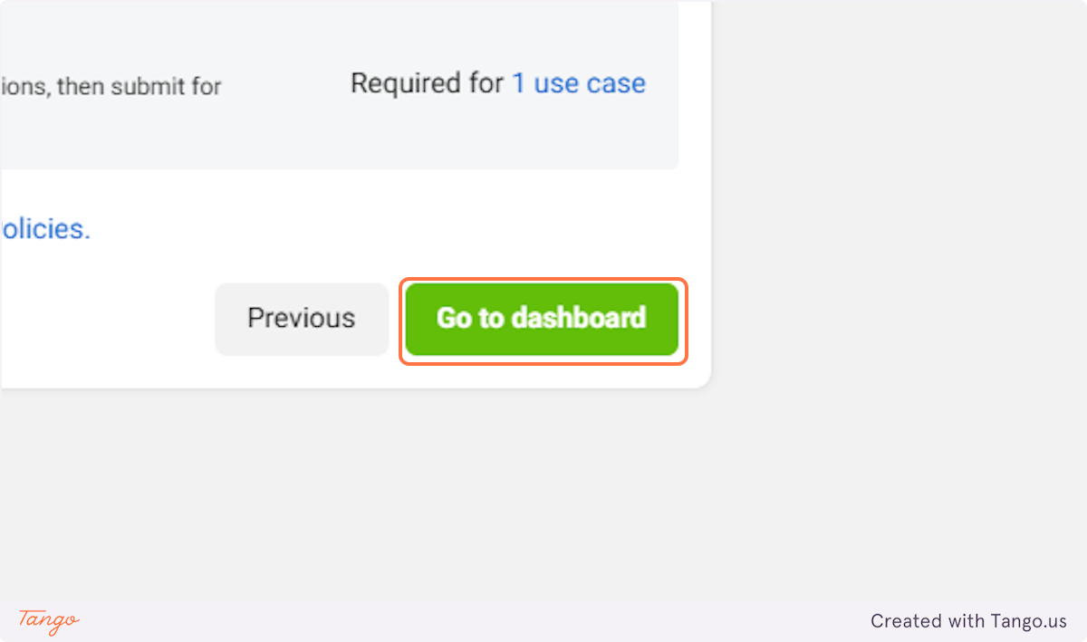

### **22. Type password**

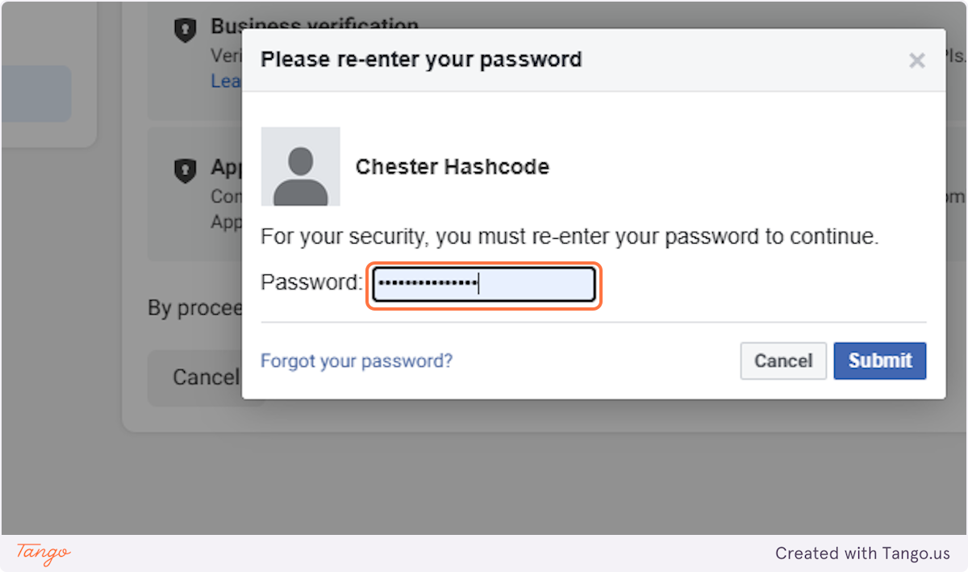

### **23. Click on Submit**

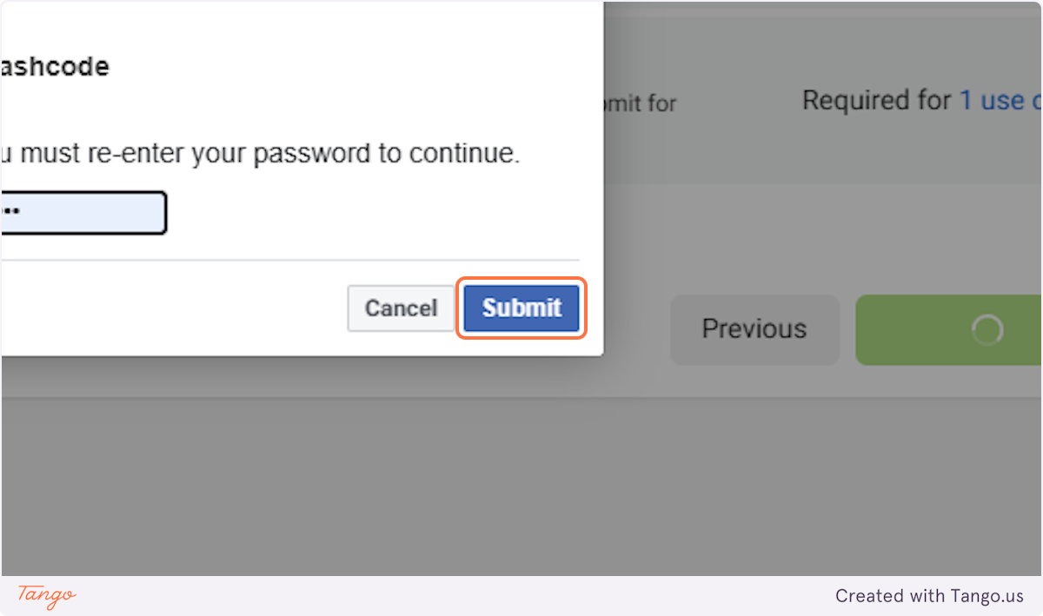

### **24. Click on ​**

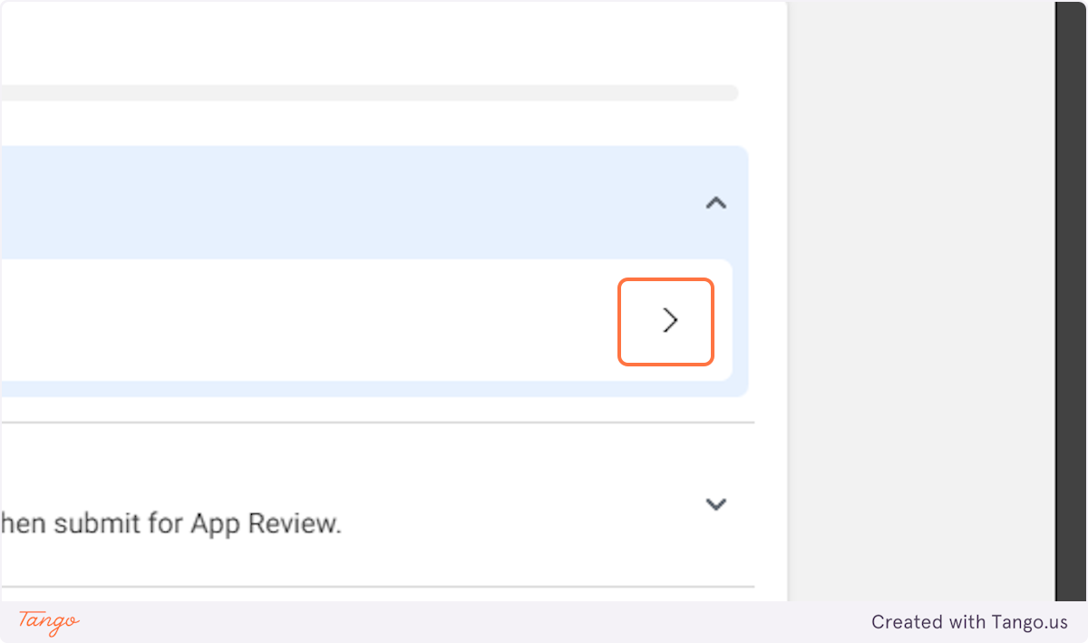

### **25. Click on Add**

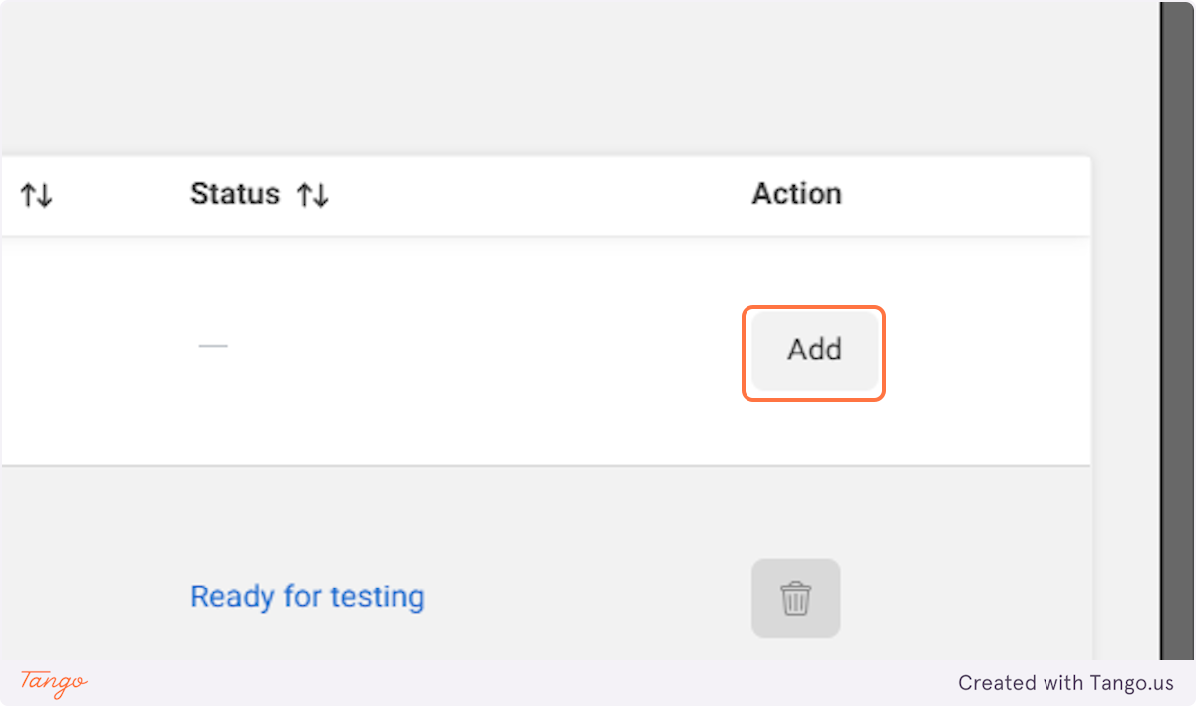

### **26. Click on Settings**

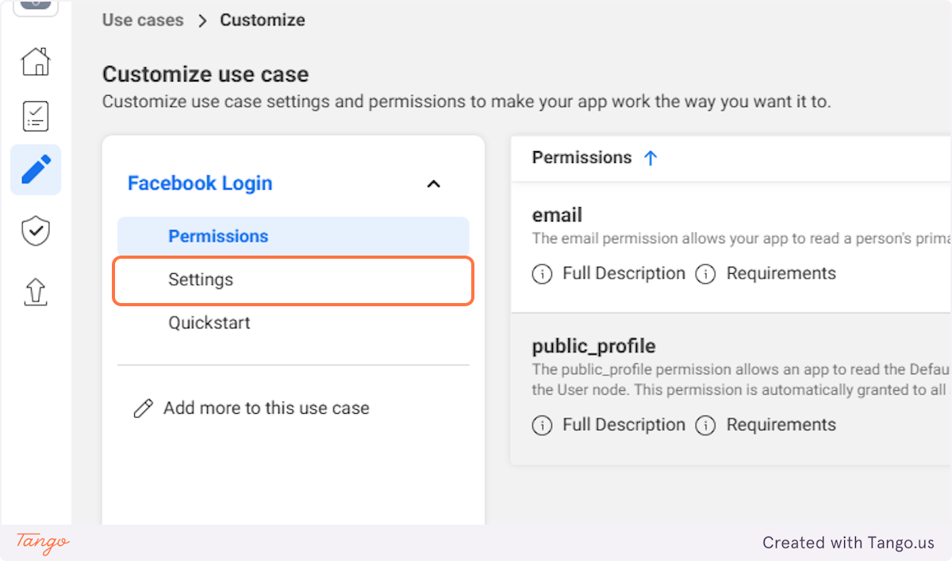

## [**# Test Game – Authentication – Sign-in method – Firebase console**](https://console.firebase.google.com/project/test-game-6af9f/authentication/providers)

### **27. Click on content_copy**

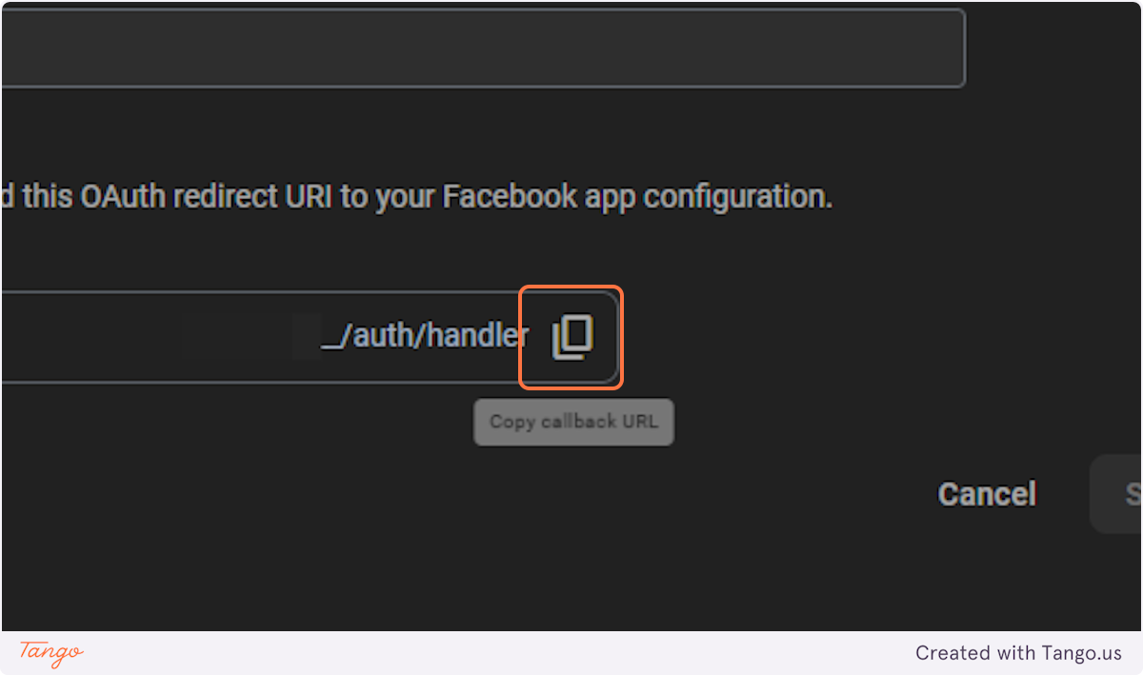

## [**# Sample App - Use cases - Meta for Developers**](https://developers.facebook.com/apps/610475754868192/use_cases/customize/?use_case_enum=FB_LOGIN&selected_tab=settings&product_route=fb-login)

### **28. Paste "https://**********.firebaseapp.com/__/auth/handler" into input**

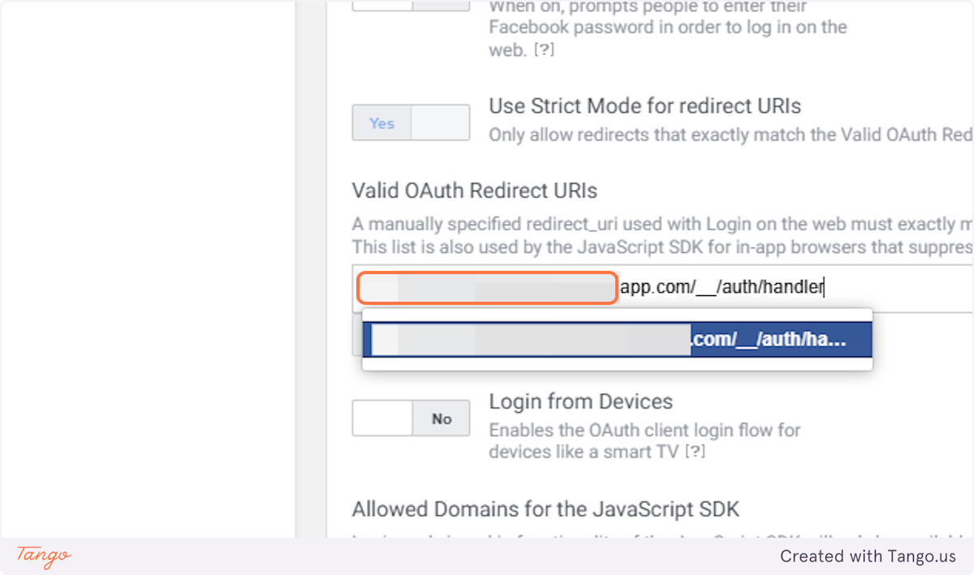

### **29. Click on Facebook Login…**

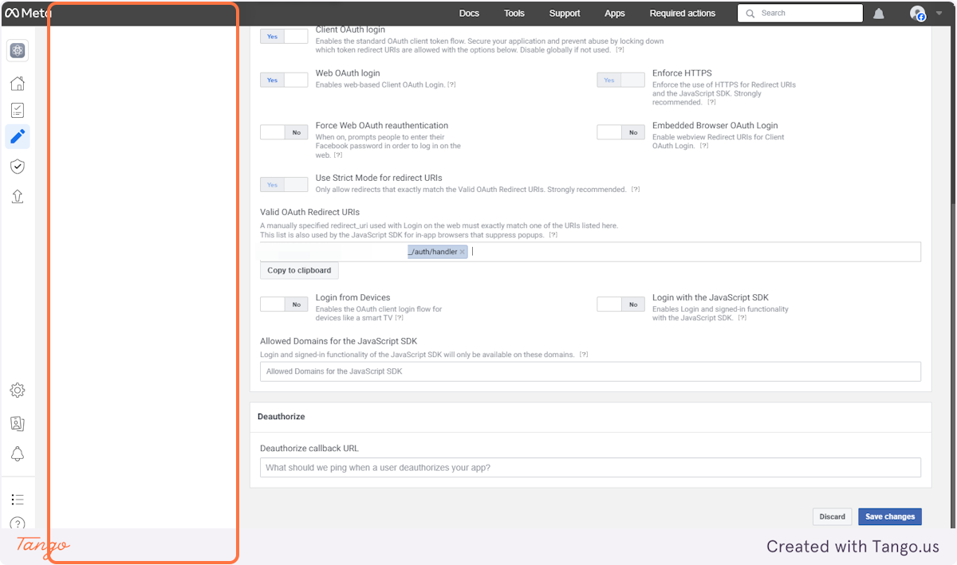

### **30. Click on Save changes**

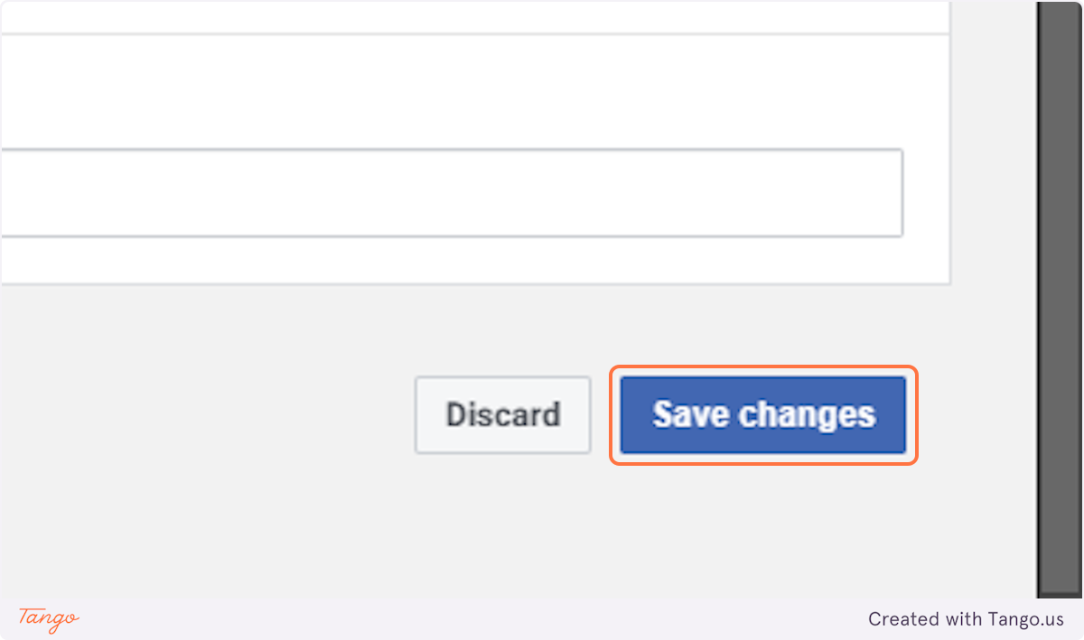

### **31. Paste "https://********.firebaseapp.com/__/auth/handler" into input**

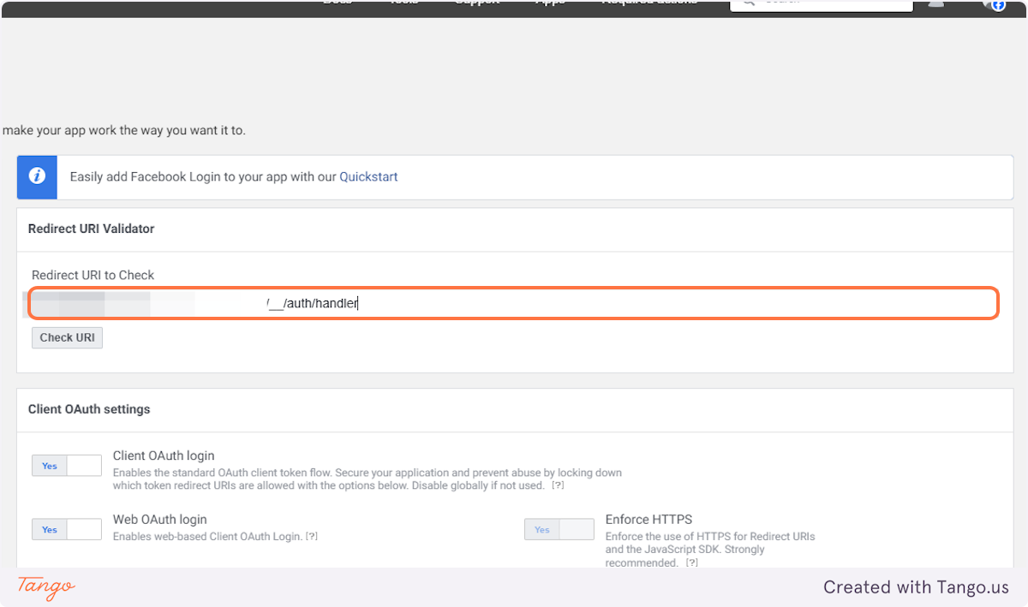

### **32. Click on Check URI**

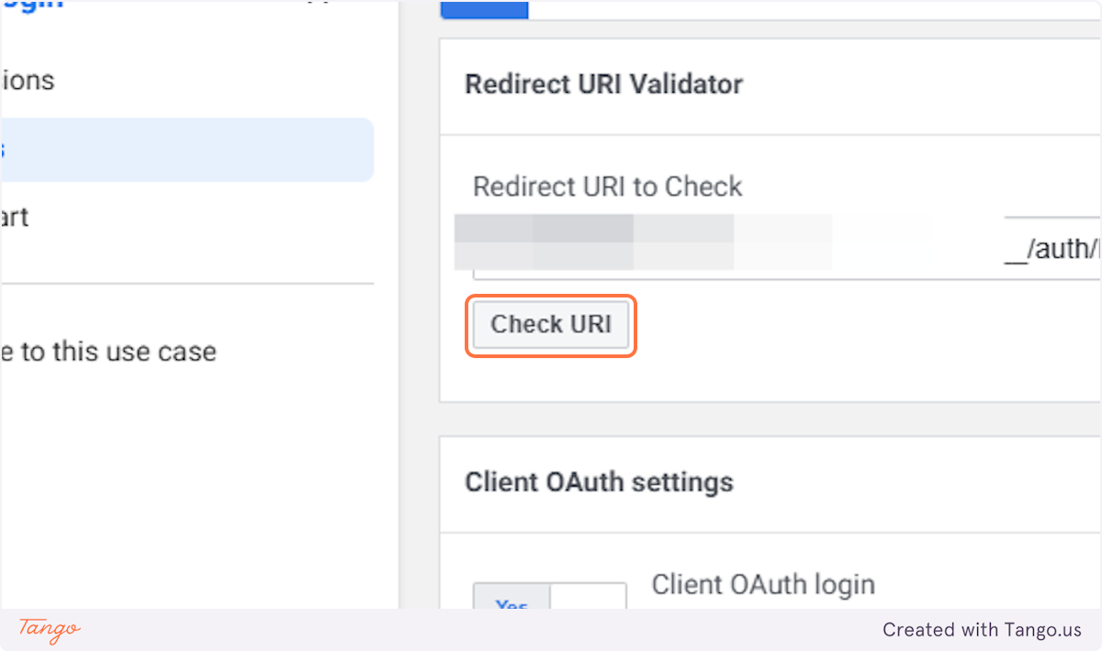

### **33. Click on App settings…**

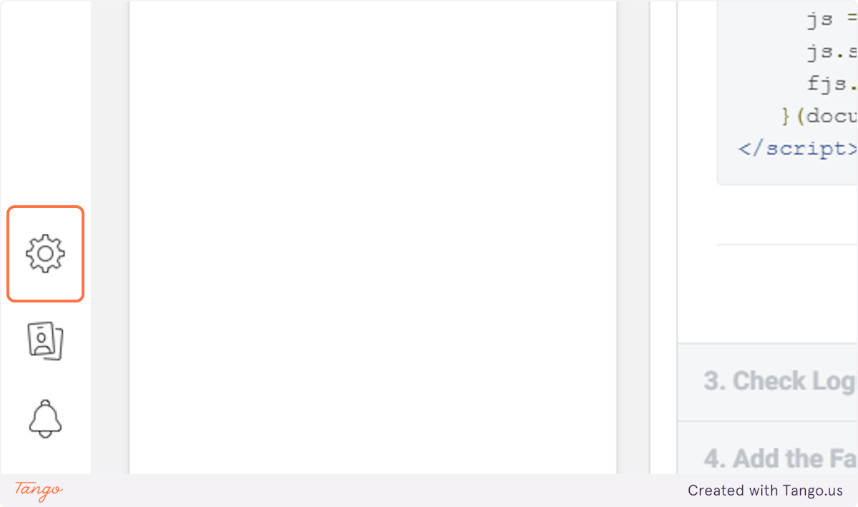

### **34. Click on Basic**

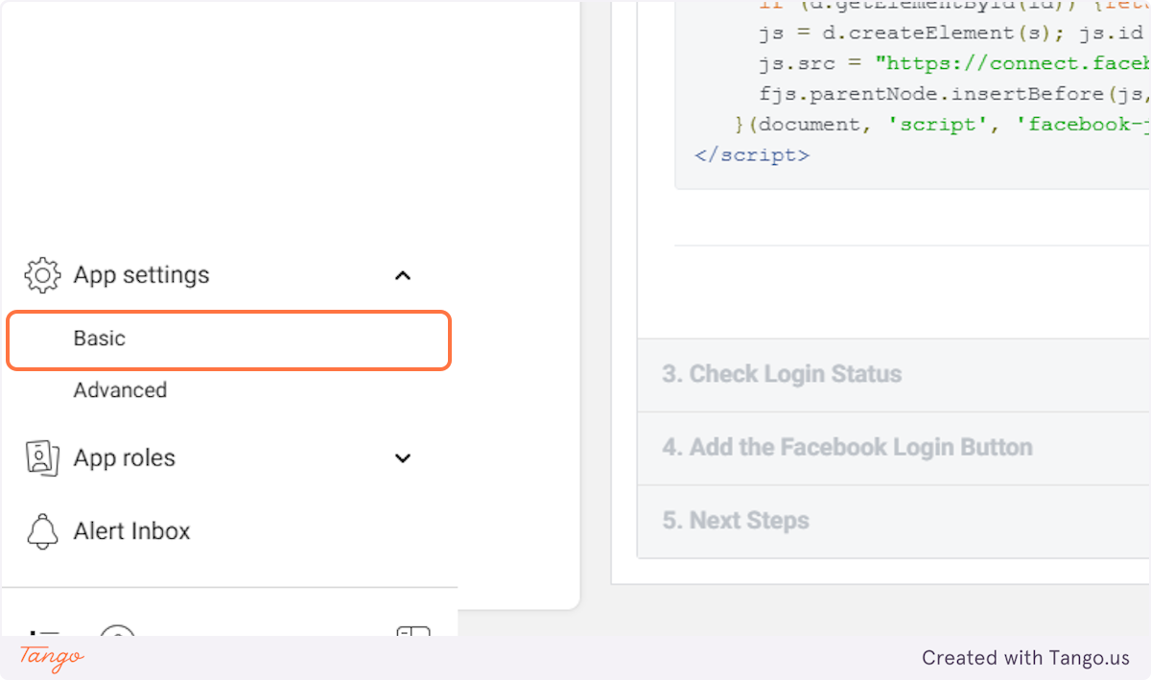

### **35. Copy input titled "App ID"**

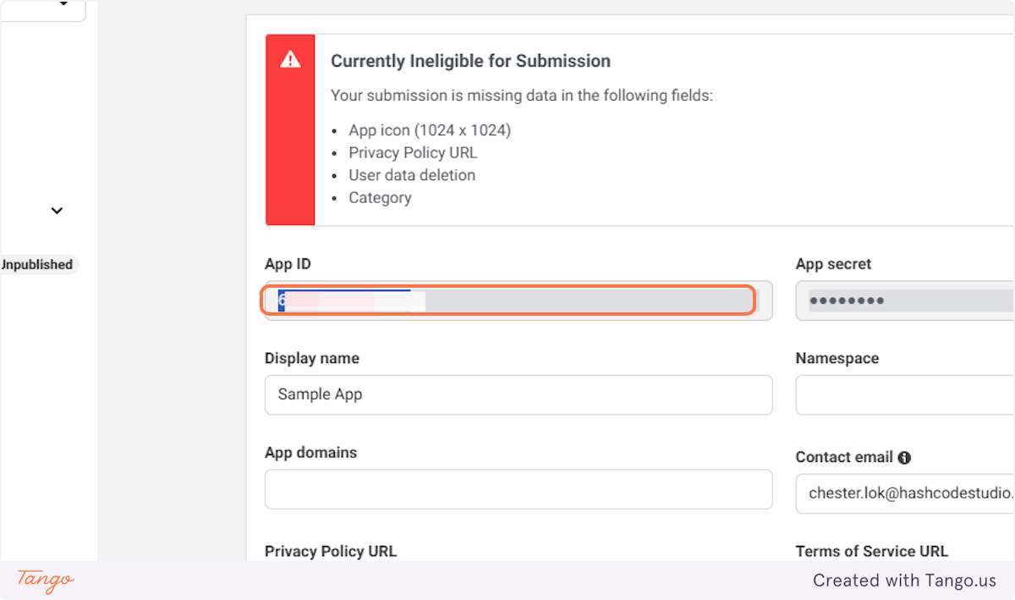

## [**# Test Game – Authentication – Sign-in method – Firebase console**](https://console.firebase.google.com/project/test-game-6af9f/authentication/providers)

### **36. Click on Facebook…**

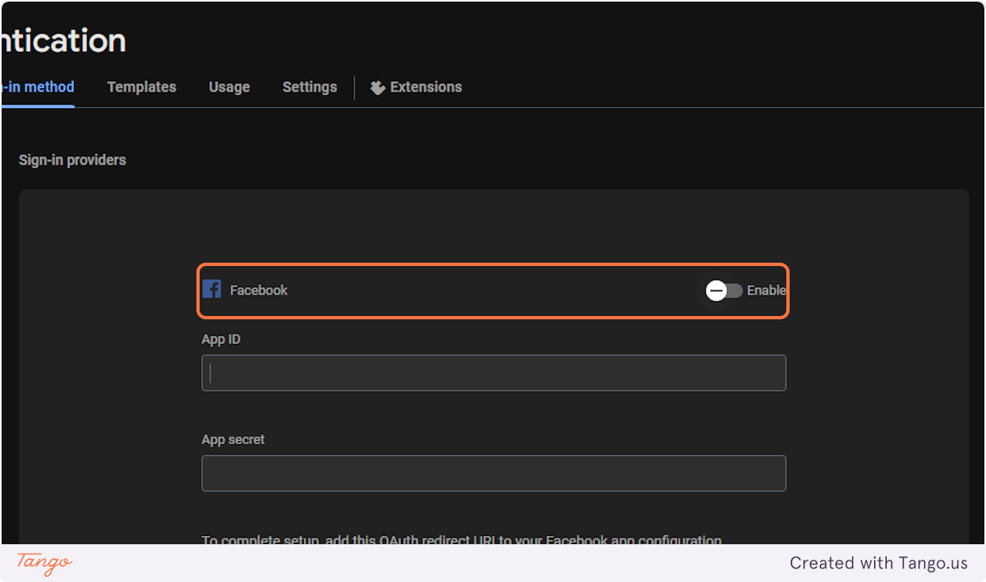

### **37. Click on Enable Facebook sign-in**

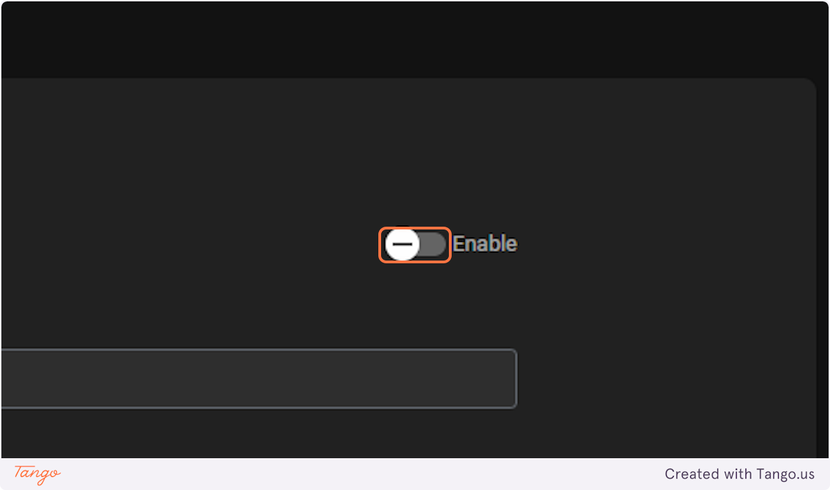

### **38. Paste "App ID" into input**

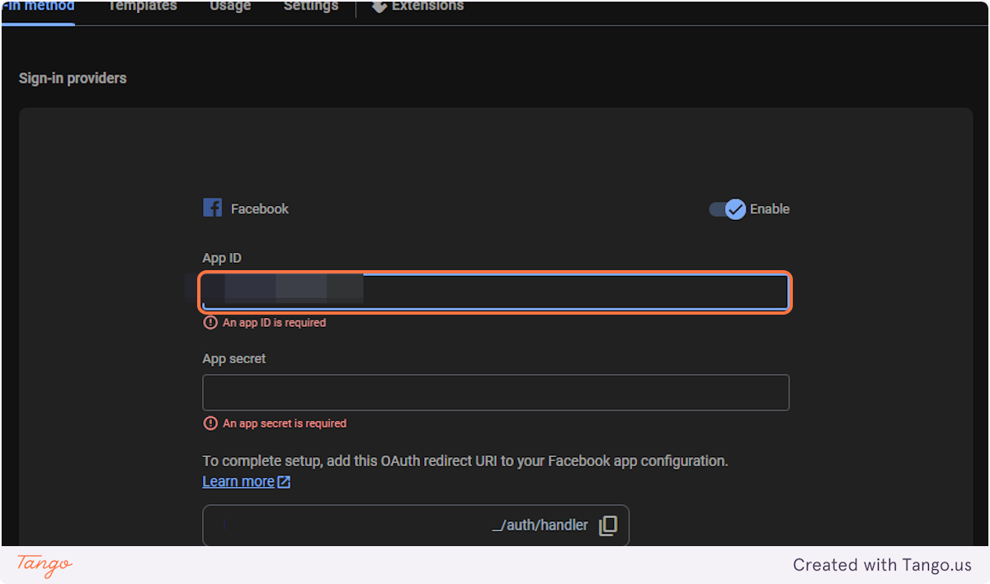

### **39. Click on App secret**

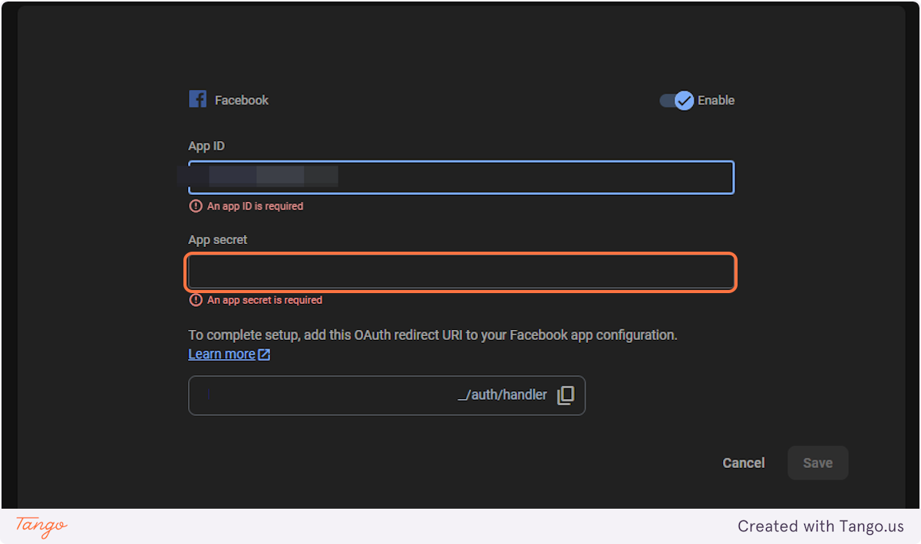

## [**# Sample App - App settings - Meta for Developers**](https://developers.facebook.com/apps/610475754868192/settings/basic/)

### **40. Click on App secret…**

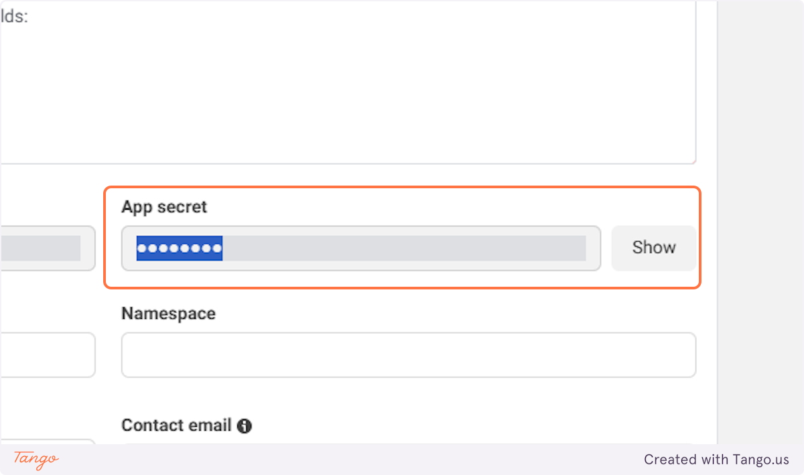

### **41. Click Show and Copy the App Secret**

## [**# Test Game – Authentication – Sign-in method – Firebase console**](https://console.firebase.google.com/project/test-game-6af9f/authentication/providers)

### **42. Paste "App secret" into input**

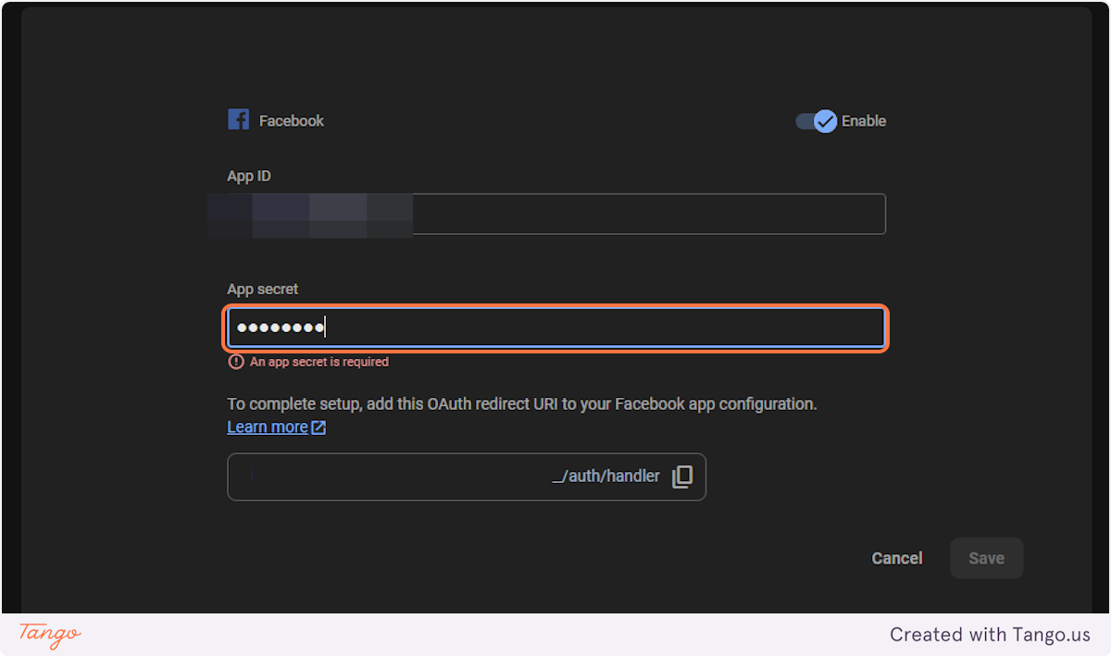

### **43. Click anywhere**

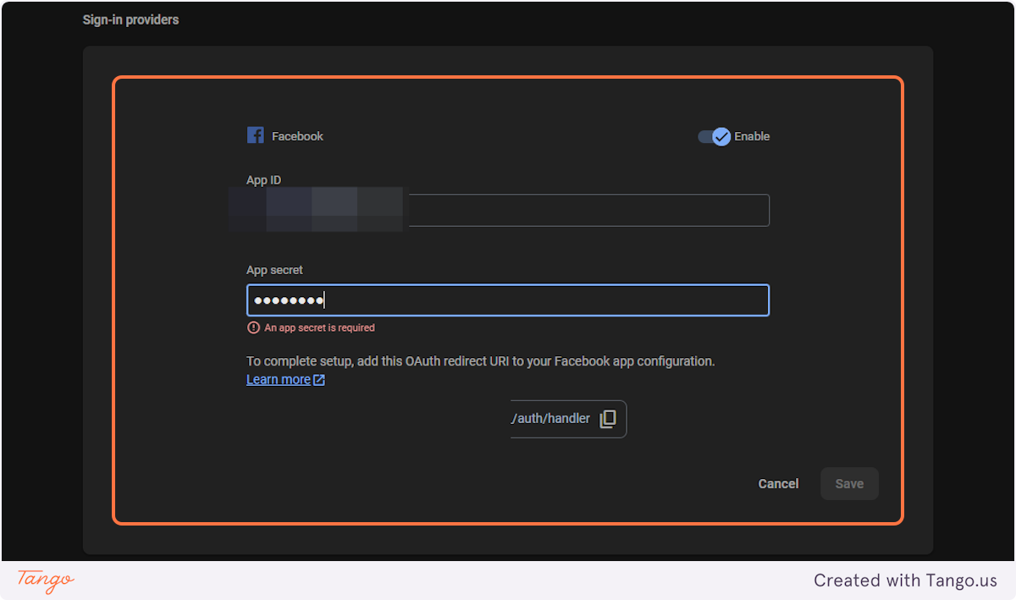

### **44. Click on Save**

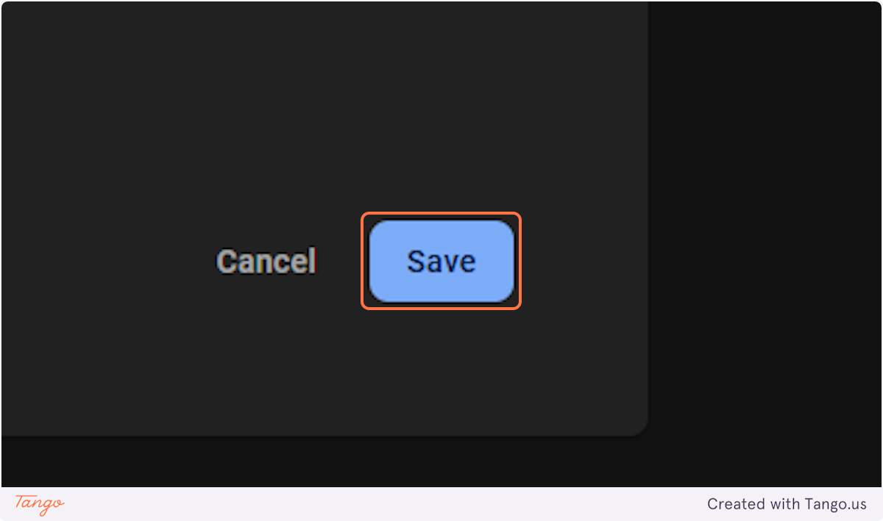

### **45. Click on Settings**

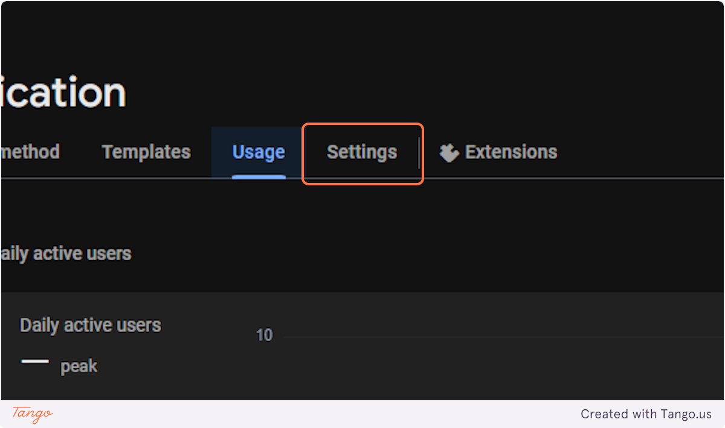

### **46. Select Create multiple accounts for each identity provider**

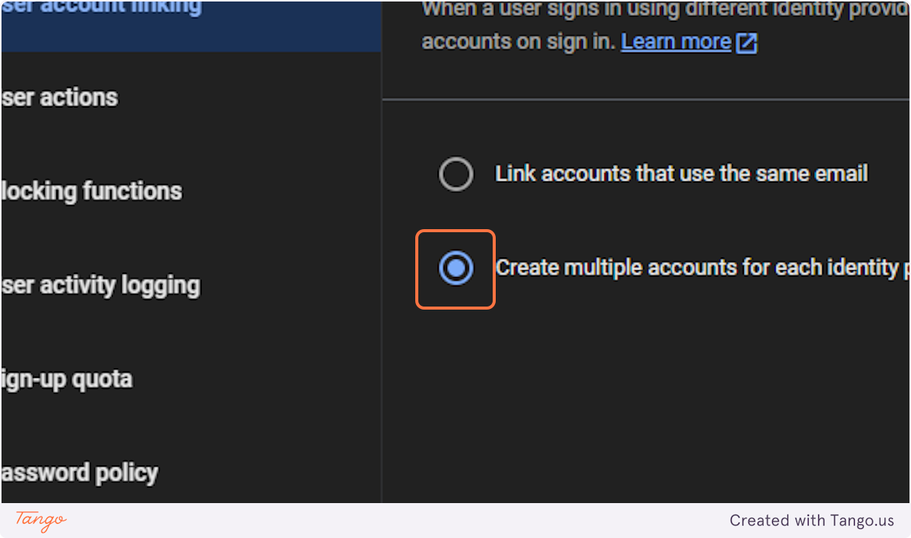

### **47. Click on Save**

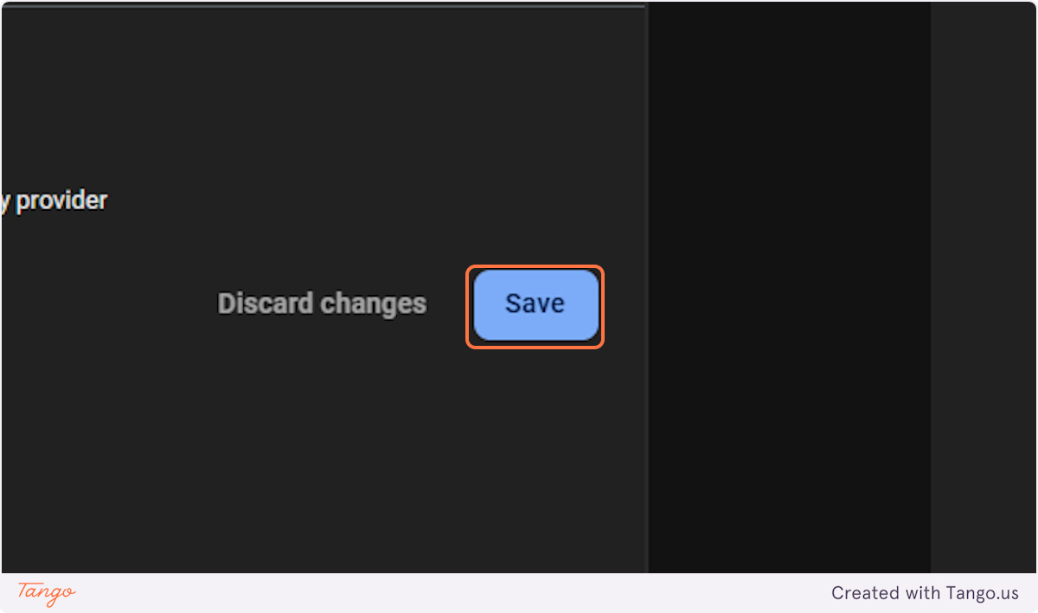

### **48. Click on gmp_nav20_settings**

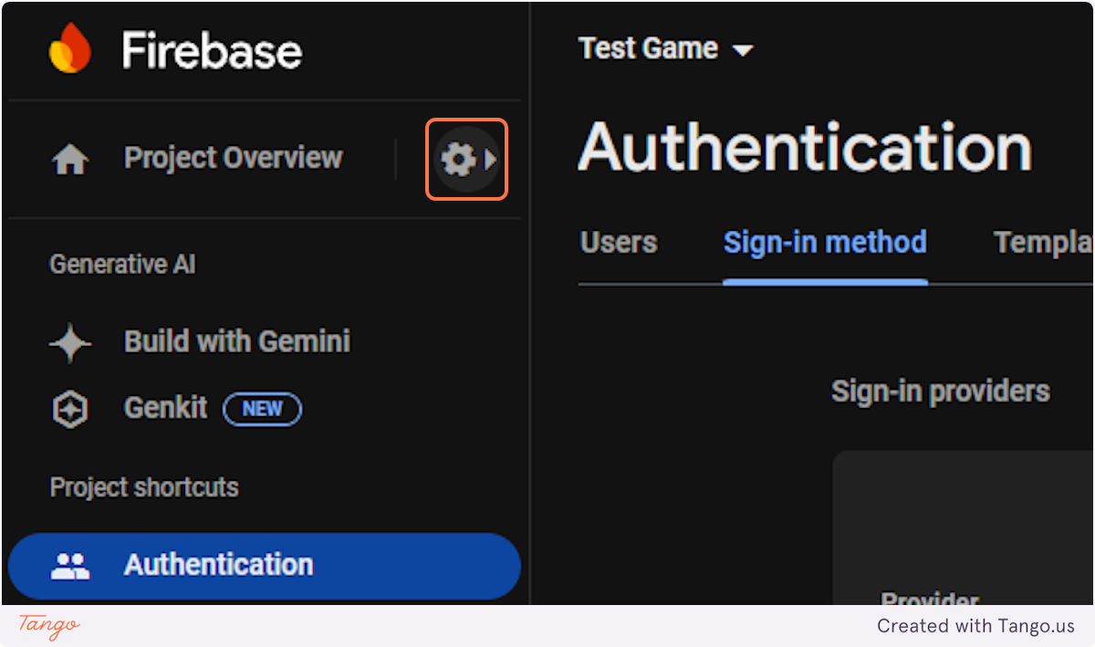

### **49. Click on Project settings**

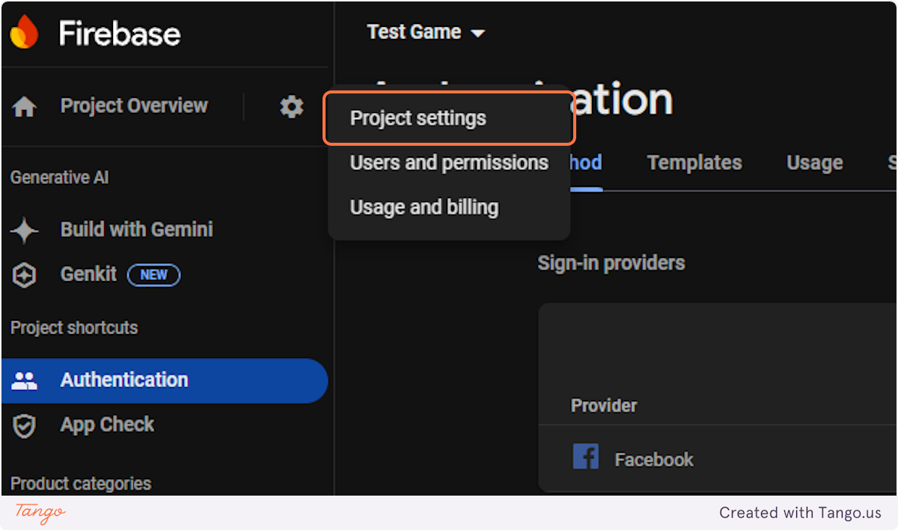

### **50. Click on Service accounts**

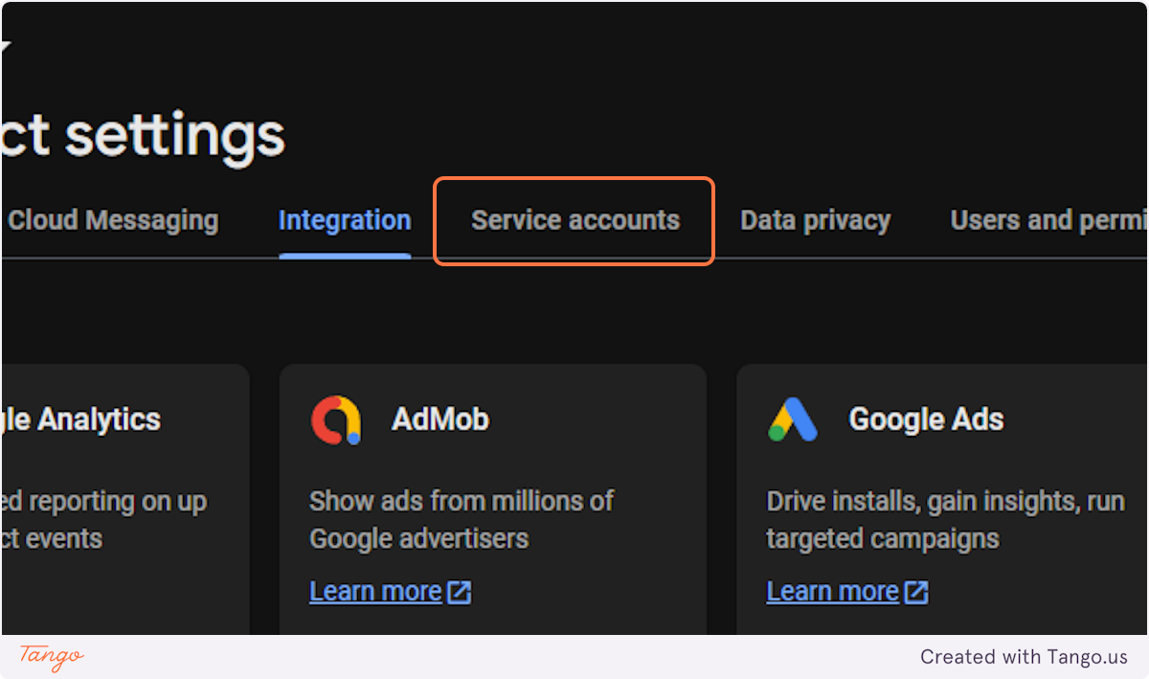

### **51. Click on Generate new private key**

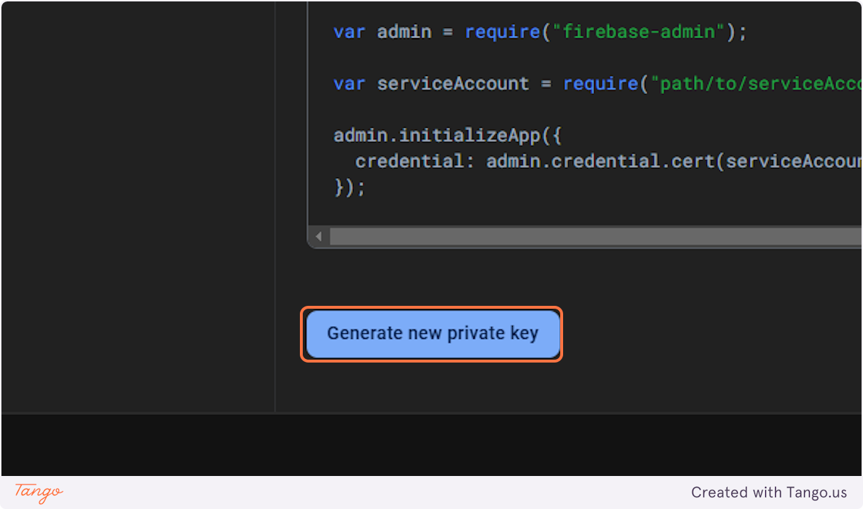

### **52. Click on Generate key and paste the json to the backend**

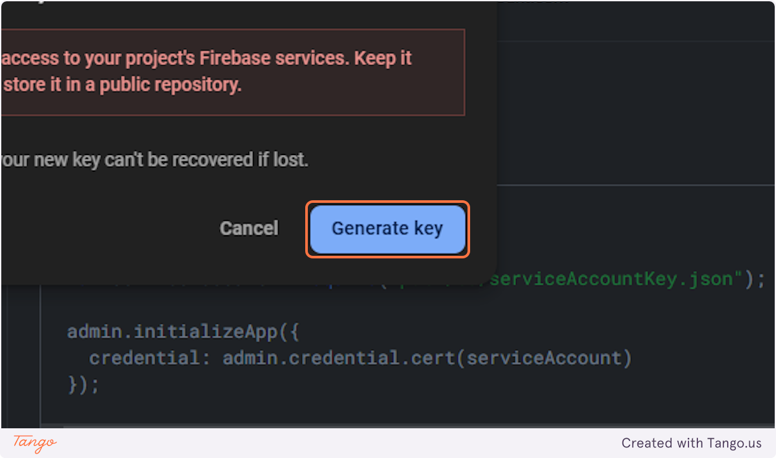

### **53. Click on General**

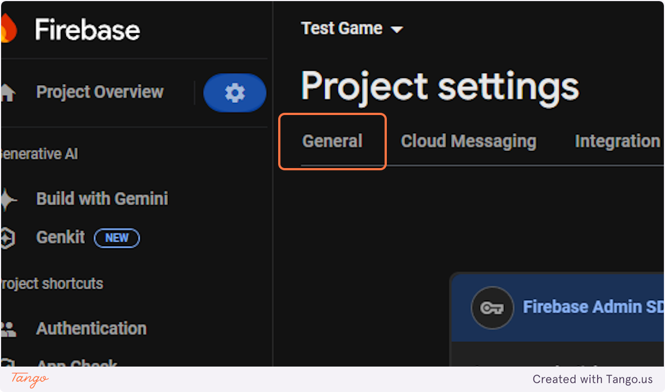

### **54. Click on plat_web**

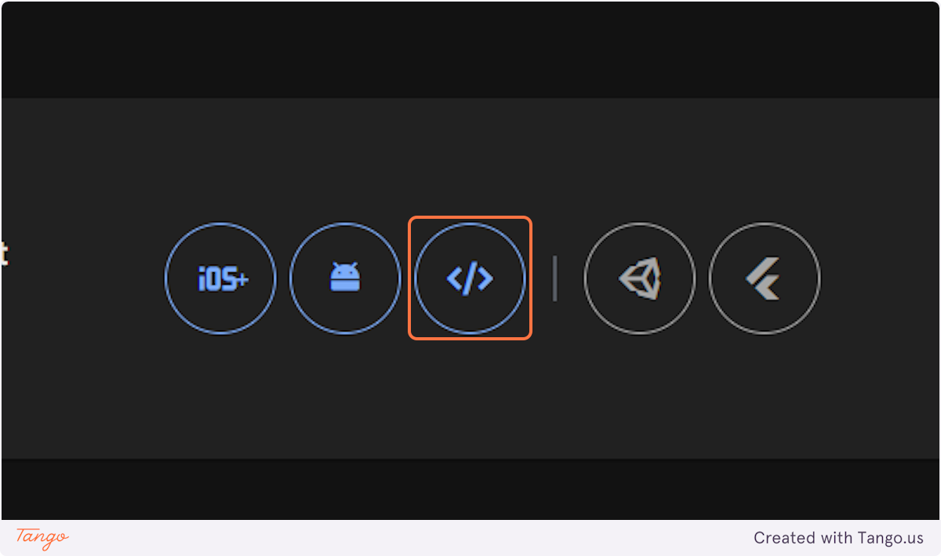

### **55. Type "Test App"**

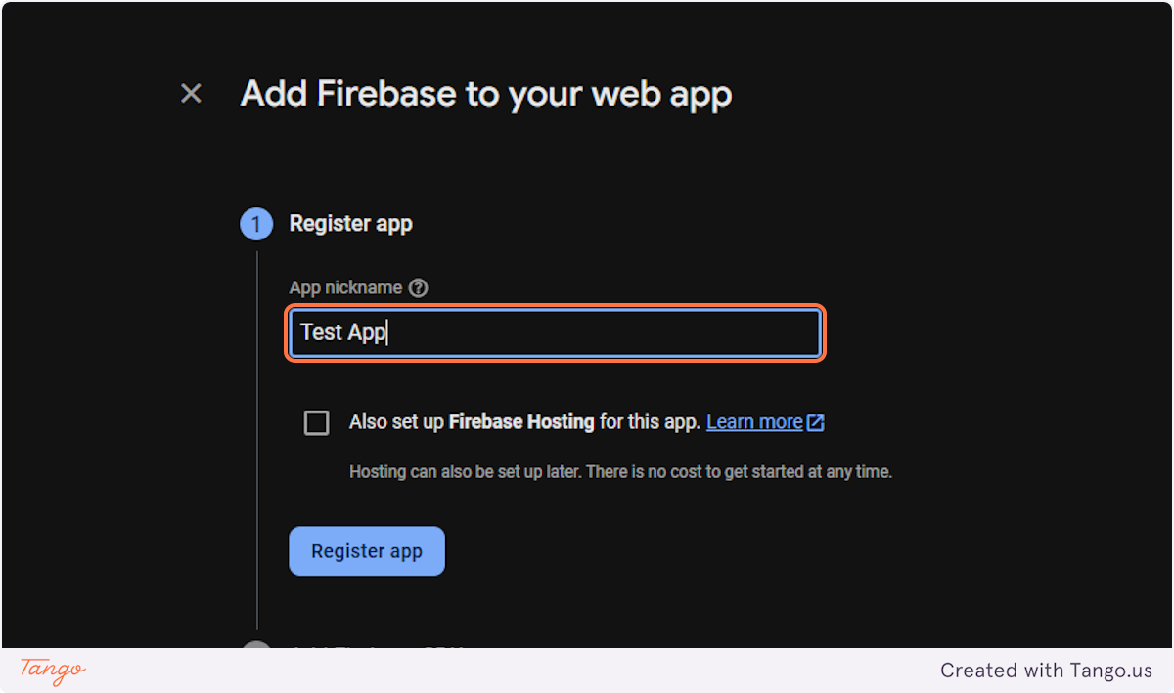

### **56. Click on Register app**

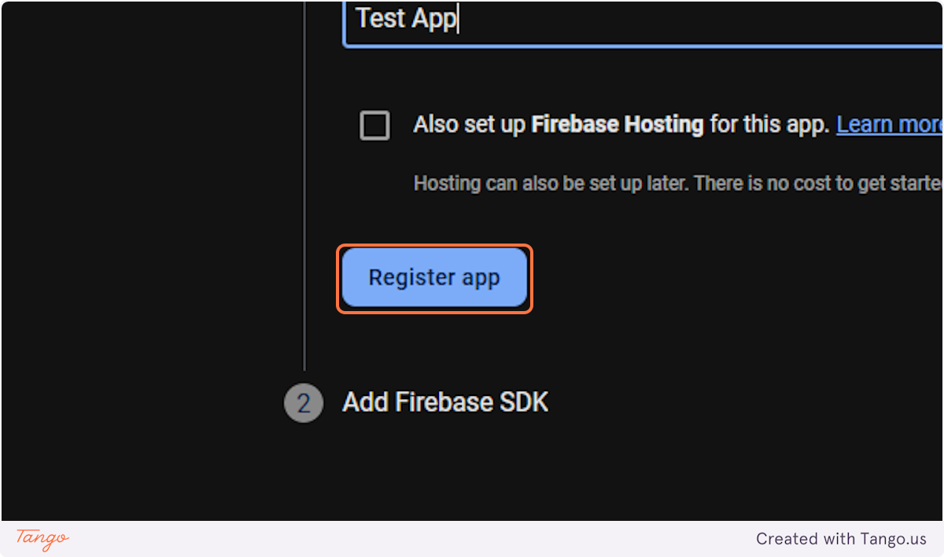

### **57. Click on Continue to the console**

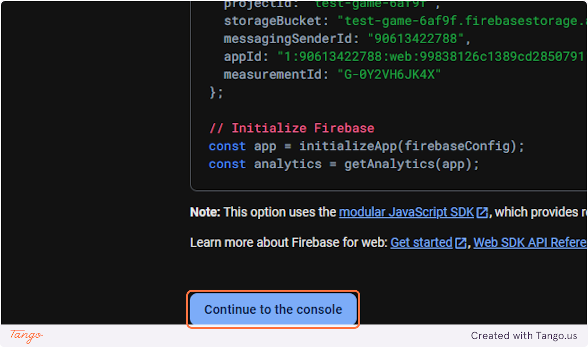

### **58. Select Config**

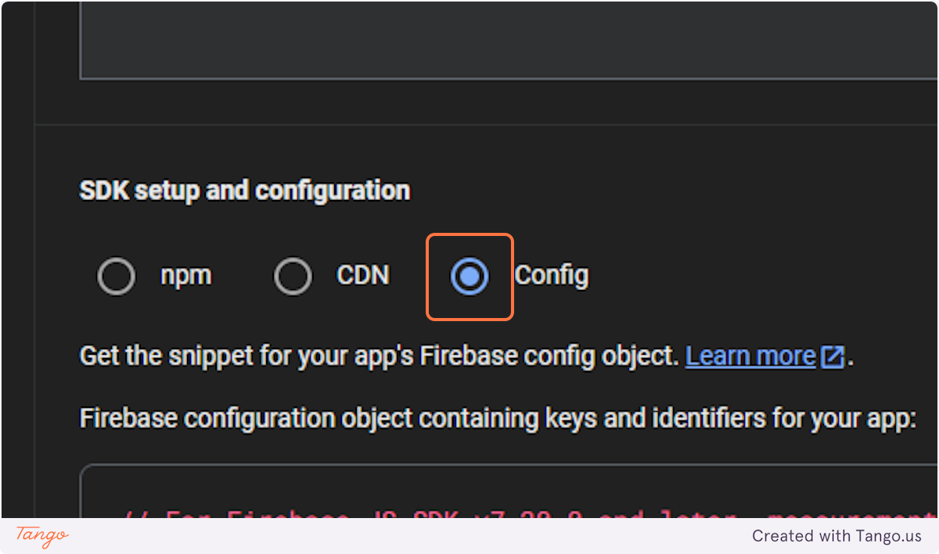

### **59. copy each of the fields and paste into .env at front-end**

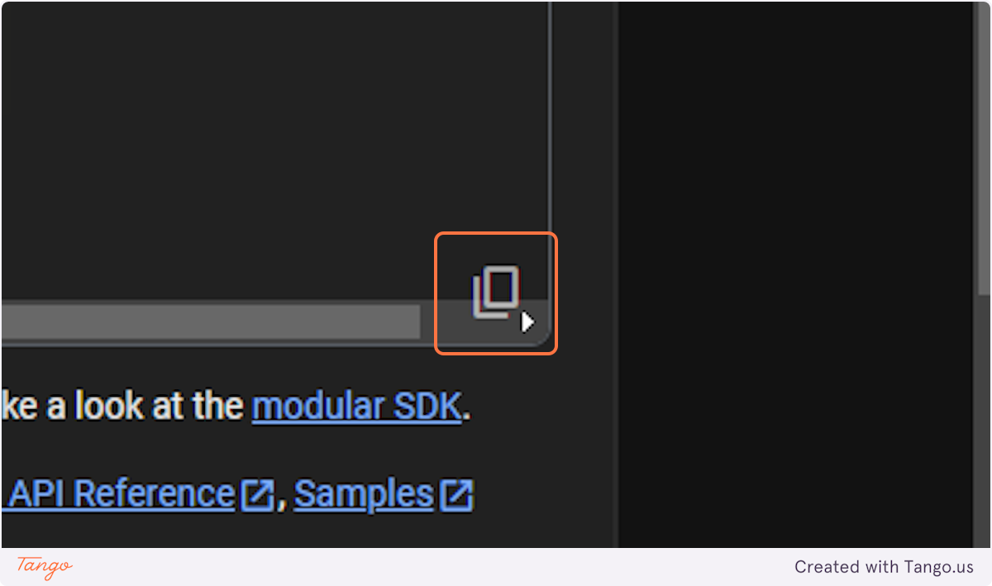

## [**# Run front end and backend using npm run start**](http://localhost:3000/)

### **60. Click on Sign in with Facebook**

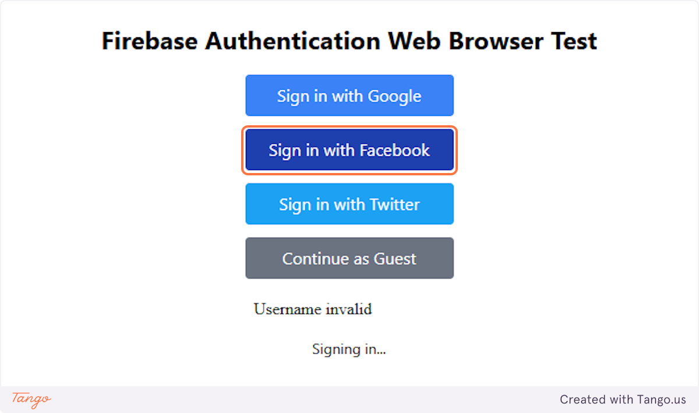

## [**# Facebook**](https://www.facebook.com/privacy/consent/gdp/?params%5Bapp_id%5D=610475754868192&params%5Bkid_directed_site%5D=false&params%5Blogger_id%5D=%22b9876b8c-fde7-482c-861c-b570127379d5%22&params%5Bnext%5D=%22confirm%22&params%5Bredirect_uri%5D=%22https%3A%5C%2F%5C%2Ftest-game-6af9f.firebaseapp.com%5C%2F__%5C%2Fauth%5C%2Fhandler%22&params%5Bresponse_type%5D=%22code%2Cgranted_scopes%22&params%5Breturn_scopes%5D=false&params%5Bscope%5D=%5B%22public_profile%22%5D&params%5Bstate%5D=%22AMbdmDlEx9m9BdW_SeA-ExkscO5_8iAQ8BSkihwd6MNpov6q_i-r0UsaqCLaNVgL6dR25IAETo3bxy8KXq3M1t95aeY9k-u9t6d0w-f4c3ztQjG6WBMBJVjLCx-_JfIKQ5BOdu9QvZom9aeMSR2MaCiPAWM_UMq0AWudOXmOe3lRBhKWuL7gxs2o0c6Oe9GpqLEzvRtsNRMiPX0d1lTDGbA1ZbDGSaRoLccm1bFWpWUC2gpgD4jq-j94Emgmn9KkAuARdubsVOEP74KdL8ro9nc__yiTi36Onlm5KxQGwPZfwKkxpqqsNMa2ZmmHscbWwjbuoM19HjZg6LbCrydfHWfJ%22&params%5Bsteps%5D=%7B%7D&params%5Btp%5D=%22unspecified%22&params%5Bcui_gk%5D=%22%5BPASS%5D%3A%22&params%5Bis_limited_login_shim%5D=false&source=gdp_delegated)

### **61. Click on Continue as *Your User Name**

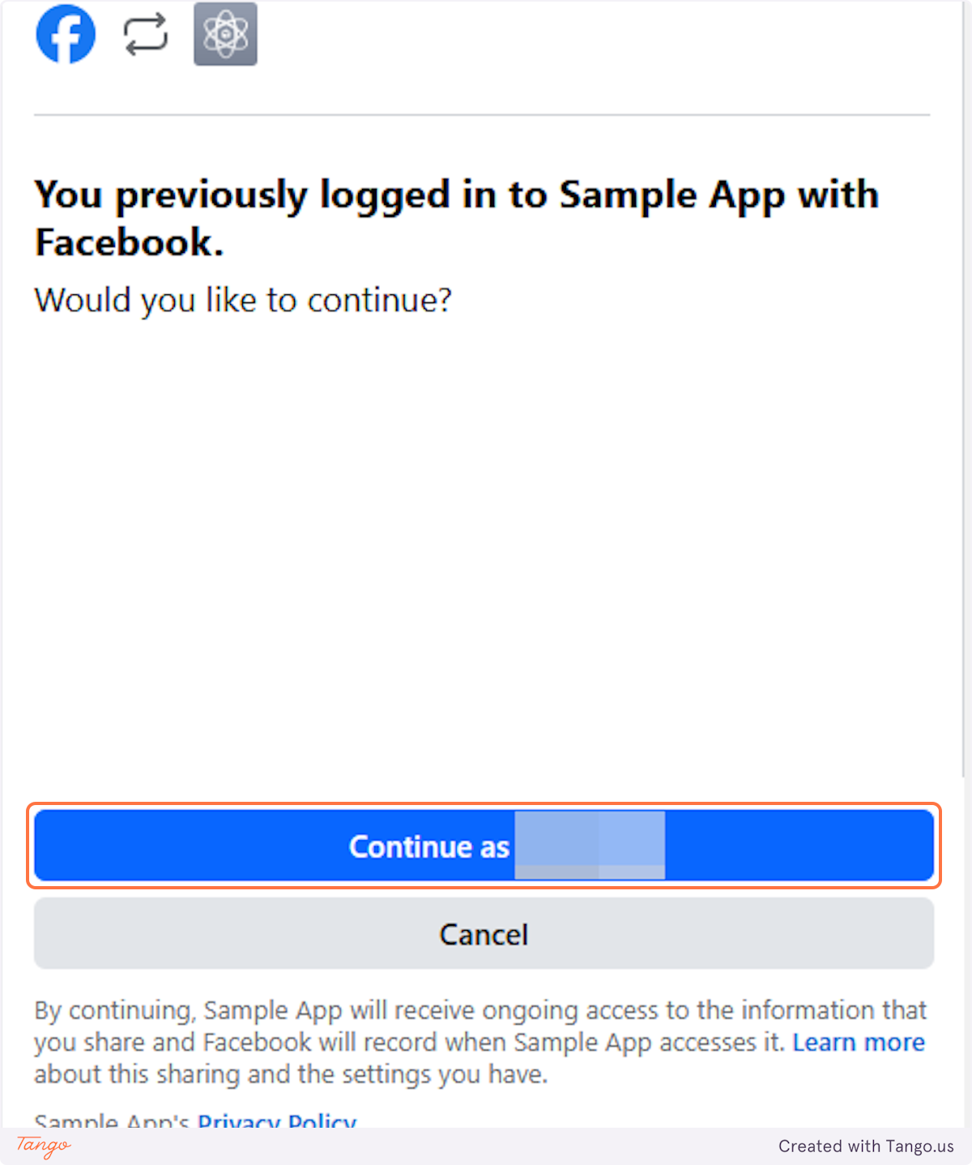

Created with [Tango.us](https://tango.us?utm_source=magicCopy&utm_medium=magicCopy&utm_campaign=workflow%20export%20links)